WINTER PLANTS THAT BLOOM IN GREECE

1. Prunus webbii Spach (Αμυγδαλιά, πικραμυγδαλιά)
(blooming from January-March)
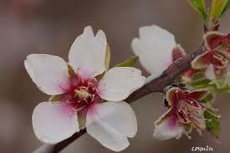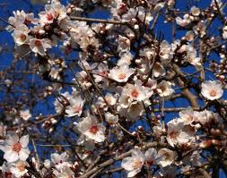
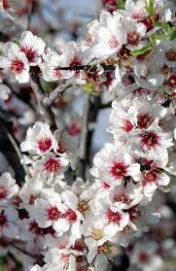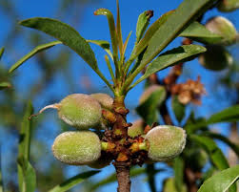

The produce contains a toxic substance which is really dangerous. The seeds contain a kind of oil (amygdalarum) which is edible.
properties: Its oil is pharmaceutical and is used for making emulsions.

2.Galanthus nivalis L. subsp. nivalis (γάλανθος ο χιονώδης)
(blooming from February-April)
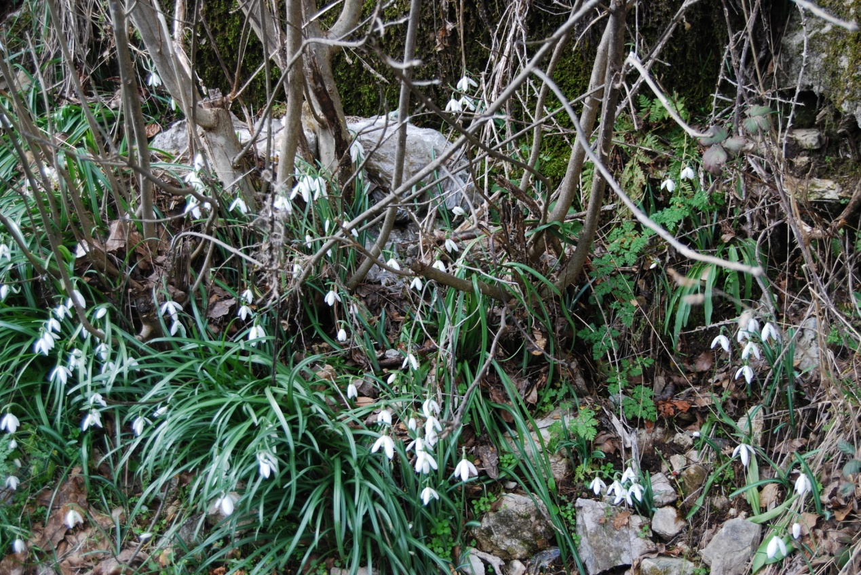
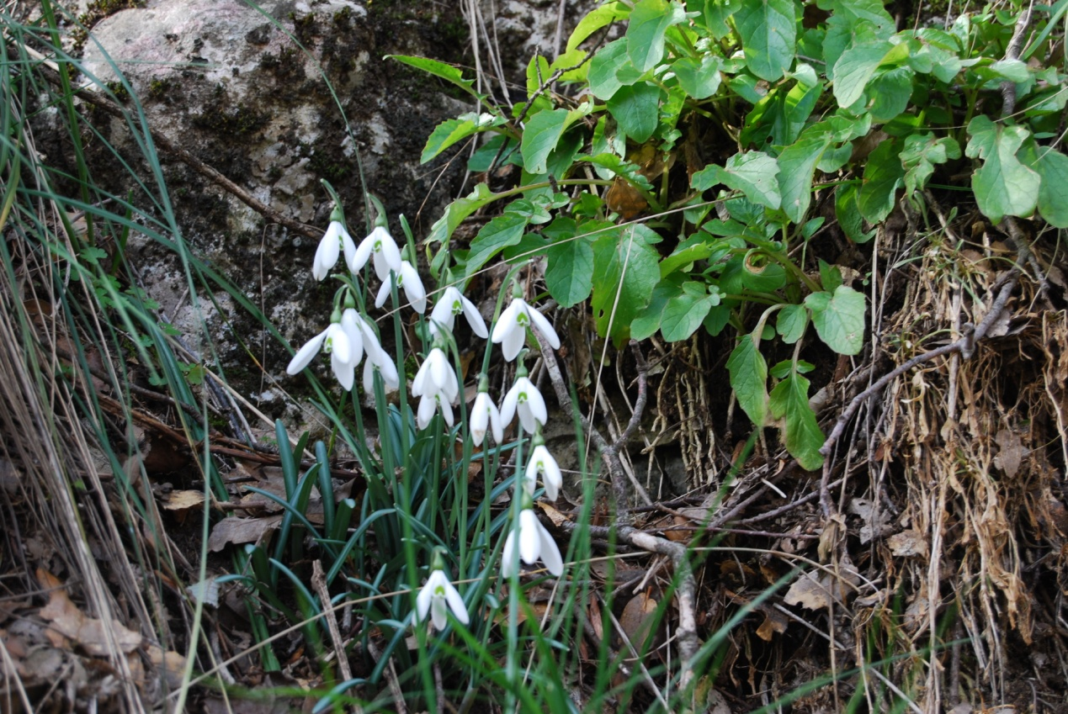

properties: The tea of the bulbs is regarded as emetic

3.Narcisus tazetta L. (γάλανθος ο χιονώδης)
(blooming from February-April)

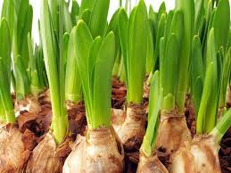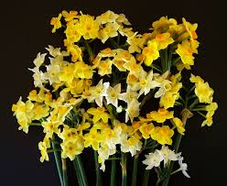

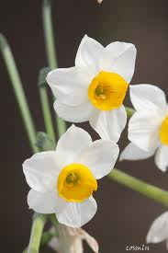

properties: The tea of the bulbs is regarded as emetic

4.Fumaria oficcinalis L. (φουμάρια η φααμακευτική, κανόχορτο, χιονίστρες, καπνιά, στάχτερη) 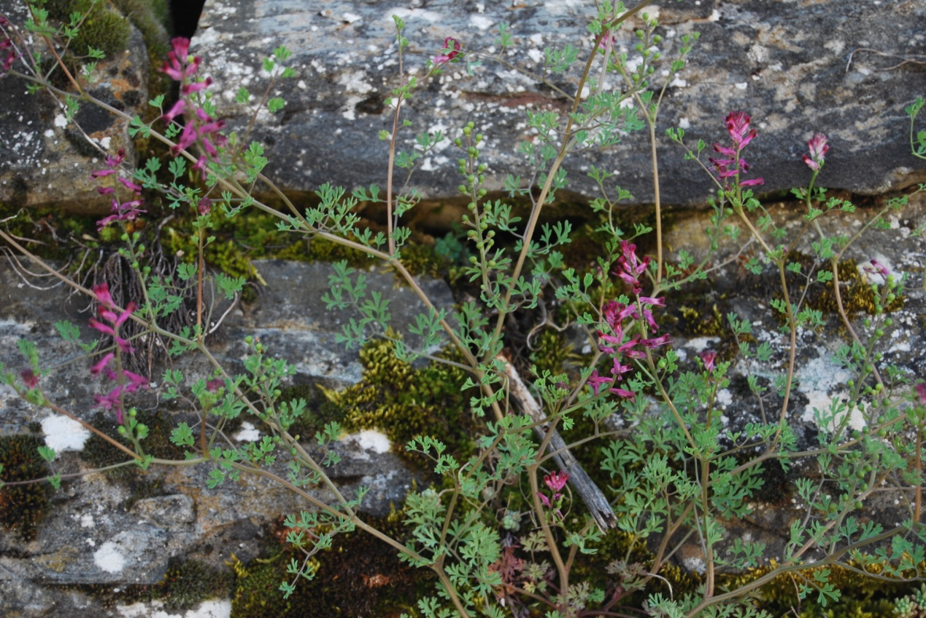

(February-May)
properties: It is used for curing/healing eczemas, dermatitis and rash. It also acts as tonic, cathartic/laxative, diuretic and helps stomach problems. It fights obesity.

