What's the weather like?

[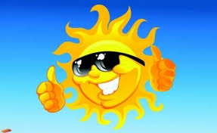](http://www.google.gr/imgres?sa=X&biw=1366&bih=597&tbm=isch&tbnid=bi_jY4e6uTGyxM:&imgrefurl=http://tastro.tlife.gr/content/articles/ilios-sinodos-dias-opsi-13-may.html&docid=o8PUwQmVMN9PSM&imgurl=http://tastro.tlife.gr/images/content_thumb954.jpg&w=423&h=259&ei=b0DxUorUGsSH4gSov4H4DQ&zoom=1&ved=0CL0BEIQcMCA&iact=rc&dur=2058&page=2&start=18&ndsp=17) [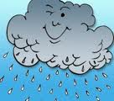](http://www.google.gr/imgres?sa=X&biw=1366&bih=597&tbm=isch&tbnid=oN8mWxdcBTCV6M:&imgrefurl=http://www.infokids.gr/2009/10/page/8/&docid=gtsdjLedVqx_ZM&imgurl=http://www.infokids.gr/wp-content/uploads/2009/10/clouds-2-170x150.jpg&w=170&h=150&ei=sEHxUmumqOIEzYeBgAo&zoom=1&ved=0CIEBEIQcMA8&iact=rc&dur=386&page=2&start=15&ndsp=15) ------------------------------------- ---------------------------------

-[](https://www.google.gr/imgres?imgurl&imgrefurl=http://kidscloud.wordpress.com/%CE%BC%CE%B5%CE%AF%CE%BD%CE%B5-%CF%83%CF%84%CE%B1-%CF%83%CF%8D%CE%BD%CE%BD%CE%B5%CF%86%CE%B1-%CE%BC%CE%B1%CE%B6%CE%AF-%CE%BC%CE%B1%CF%82/&h=0&w=0&sz=1&tbnid=LeY1S1fpE45dyM&tbnh=160&tbnw=240&zoom=1&docid=GH1xzCI32PySeM&ei=RUPxUoLBDqbB0QW30oDACA&ved=0CAIQsCUoAA) [](http://www.google.gr/url?sa=i&rct=j&q=&esrc=s&source=images&cd=&cad=rja&docid=S5tFEZ9rr3w_nM&tbnid=V4df6BkElBmEcM:&ved=0CAUQjRw&url=http://gr.forwallpaper.com/wallpaper/winter-christmas-trees-snow-vector-clouds-purple-296967.html&ei=EkTxUomjJePN0QW59IHACw&bvm=bv.60444564,d.bGE&psig=AFQjCNHD3lZedtAhRGk0g1d2iB_wI-7FIA&ust=1391629692632647)

--------------------------------------- -----------------------------------------

[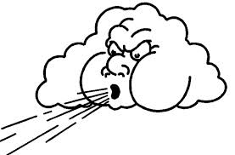](http://www.google.gr/url?sa=i&rct=j&q=&esrc=s&source=images&cd=&cad=rja&docid=hbtojam2HBJZkM&tbnid=4WaTaZSkR8KgaM:&ved=0CAUQjRw&url=http://kolindrinamaslatia.blogspot.com/2012/02/blog-post_9429.html&ei=N0XxUqjEE4aO0AW-54CYAQ&bvm=bv.60444564,d.bGE&psig=AFQjCNHo8MawUucOrssgnnYYdpbwNU4E8A&ust=1391629960325120)

--------------------------------------

Angela X.(4th grade)