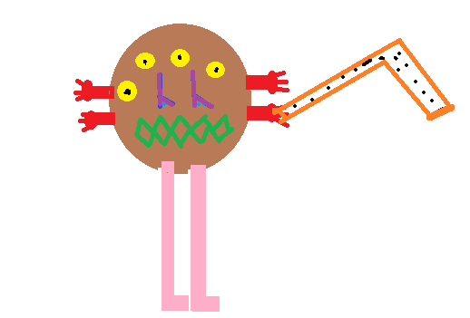WANTED
A BROWN MONSTER WITH FOUR YELLOW EYES, TWO PURPLE NOSES, A STRANGE MOUTH, FOUR RED HANDS AND TWO LONG PINK FEET. BE CAREFUL!!IT HAS AN ORANGE AND DANGEROUS GUN. IT IS SAVAGE, DANGEROUS AND REALLY DISGUSTING!
IF YOU FIND IT CALL US AT: 6473652309.
ΥOUR REWARD IS 120.000EURO

BY Aspa (6th grade)

