WALES
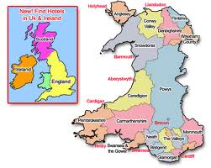

Wales is a mountainous country on the Western side of Central-Southern Great Britain.
BORDERS
West: England North-West: Irish Sea South-west: St George's Channel & the Celtic Sea
South: British Channel

POPULATION: 3,OO6,430

CAPITAL CITY: Cardiff (population:341,054)
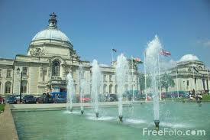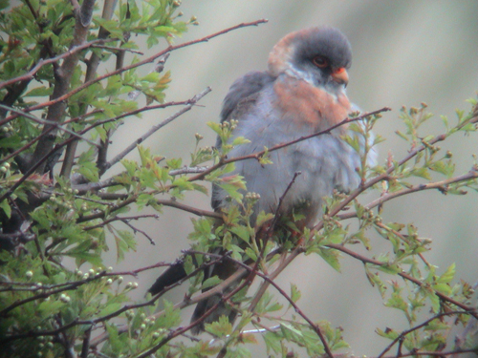

Other Major Cities
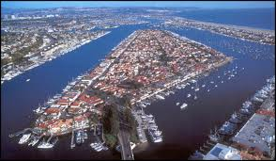 Newport

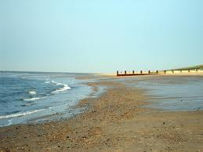 Wrexham

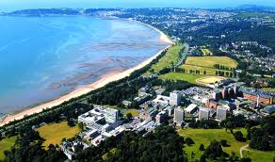Swansea

NATIONAL LANGUAGES: Welsh- English

GOVERNMENT: Welsh (the Welsh government says, "Wales is not a principality. It is a country by itself. The Prince of Wales does not play a role in the Welsh Government".

PATRON SAINT: St David
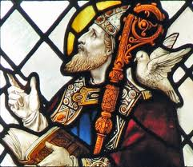

CURRENCY: Pound (English sterling)
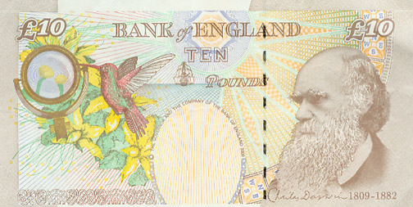pound note

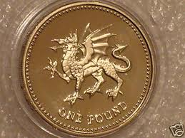pound coin

SPORTS: Football, rugby, cricket

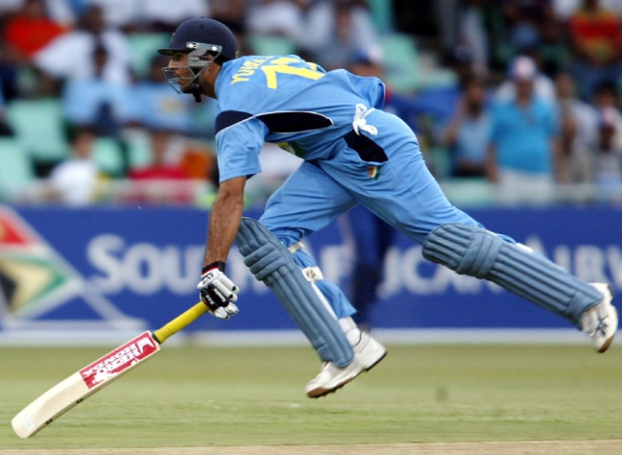 CRIKET

NATIONAL FLOWER: Daffodil

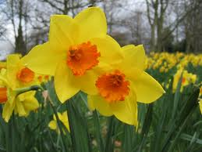

NATIONAL MUSICAL INSTRUMENT: The Harp
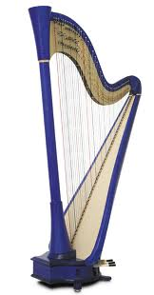

NATIONAL FLAG: The Red Dragon
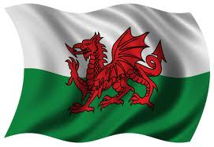

HISTORY
PREHISTORIC ERA: Homo Sapiens appeared in Wales 33.000 years ago. Modern human appeared 28.000 years ago.
ROMAN ERA: Romans conquered Wales in 48 BC. They stayed there foe 300 years.
POST-ROMAN ERA: Anglo-Saxons (German tribes) invaded Wales around 500 (until 1066)
1216: The 1st Prince of Wales
1282: King Edward I conquered Wales
15th century: Revolts against the British rule
1707: Wales became part of Great Britain (but it kept its language & culture)
IMPORTANT DATE: 1588 the first translation of the Bible in Welsh by Welsh Bishop William Morgan 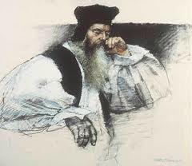

-------------------------------------------------------------------------------------------------------------------------------------------------------------------------------------------------------------------------------------------------------------------------------------------------------------------------------------------------------------------------------by
(by the pupils of the 5th class (Model Experimental Primary school of Patras) October 2012

