The Rio–Antirrio bridge, officially the Charilaos Trikoupis Bridge after the statesman who first envisaged it, is the world's longest multi-span cable-stayed bridge. It crosses the Gulf of Corinth near Patras, linking the town of Rio on the Peloponnese to Antirrio on mainland Greece by road.
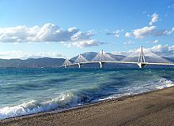

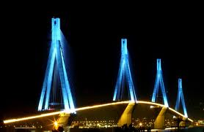
The bridge was planned in the mid-1990s . The lead architect was Berdj Mikaelian. Site preparation and dredging began in July 1998, and construction of the massive supporting pylons in 2000.
On May 21, 2004, the main construction was completed; only equipment (sidewalks, railings, etc.) and waterproofing remained to be installed.
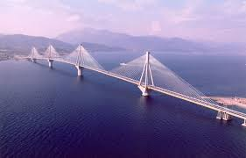

FAIDRA V.
IOKASTI K.

