The ancient Roman Odium of Patras

The Roman Odeon of Patras is a magnificent building from Roman times. Today it has been reconstructed and used for musical events . Located west of the Castle , Upper town next to the Roman arena and among the streets of Old Patras Germanos Sotiriadou, Pantocrator and Saint George Square . The Odeon was built probably in the reign of Augustus . Pausanias reports that it was older than the Odeon of Herodes Atticus .
Over the years the Conservatory was damaged by natural disasters and raids...

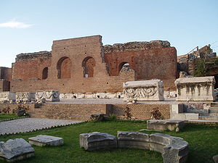
Currently the Conservatory is open to visitors and is often hosts musical events.

