THE MYTH OF PERSEPHONE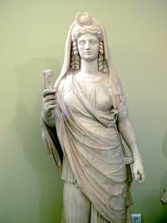

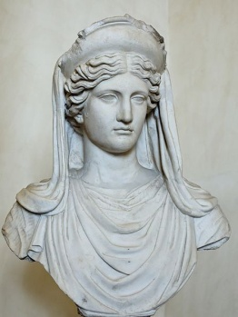 Demeter ( the goddess of agriculture)
had a beautiful daughter called Persephone. Persephone's father was Zeus, the Father of Gods. He decided to marry her with Hades, the God of the Underworld. One day, as Persephone was picking flowers in the forest, Hades abducted her.
Demeter went all over looking for her beloved daughter. She could not find her anywhere. With pain and tear in her eyes, she begged the God Helios (the Sun) to tell her what had happened to Persephone. Helios told her that Zeus gave her to her as a wife.
Demeter became very angry with this decision of Zeus. She left the Mount Olympus, the Gods' residence, and she transformed herself into a regular mortal woman. Dressed in black she walked among the humans crying for her daughter. Because of this, nothing was growing on Earth. Humans and animals were starving and slowly dying.
Zeus was watching from Olympus. He did not want life on Earth to disappear. So He sent Goddess Iris to tell Demeter to return to Olympus. Demeter denied his request. Zeus sent other Gods to beg her to return. Her answer was that she would come back only if Hades brought Persephone back to her. Therefore Zeus talked to Hades who agreed to let Persephone return to her mother for a long part of the year.
From then on, two thirds of the year Persephone lives with Demeter. This is the time on Earth that everything grows. The tress and the plants are green and are producing their goods. These are the seasons of Spring, Summer and Autumn. The rest of the year Persephone returns to the Underworld to live with her husband and Demeter, again sad, makes the Earth unfruitful. This is the season of Winter. With this myth the ancient Greeks explained the cycle of the seasons.
By Myrsini, Anna, Peter, Theodore, Alex & Dennis

