THE MYTH OF PERSEPHONE IN PICTURES
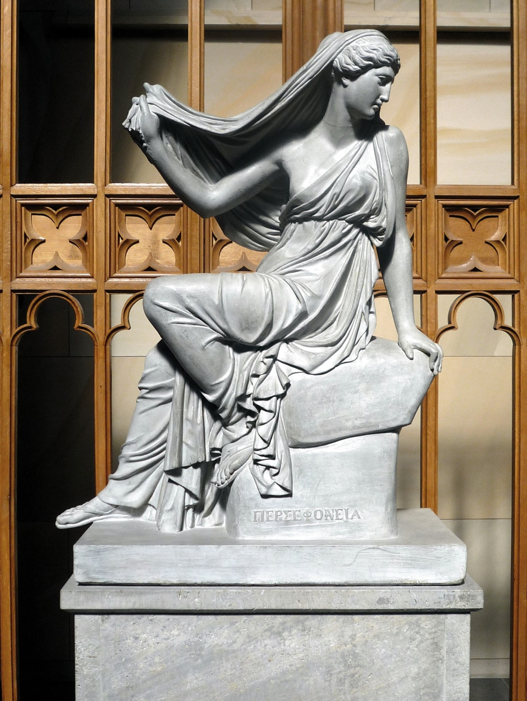
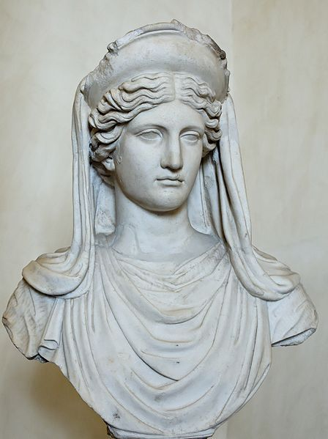 DEE THE GODDESS OF AGRICULTURE DEMETER
TH
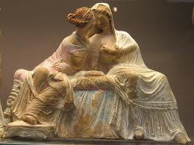 THE GODDESS DEMETER & HER DAUGHTER PERSEPHONE
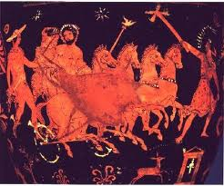THE ELOPMENT OF PERSEPHONE BY HADES: (DEMETER'S BROTHER) GOD OF UNDER WORLD- OF DEAD & DEATH-
DEMETER GOES TO HADES TO TAKE HER DAUGHTER BACK
DEMETER BRINGS PERSEPHONE BACK ON EARTH (after the deal Zeus made with Hades, according to which from then on Persephone would stay on earth for a long period of time and would go back to Hades for only 4 months of the year)
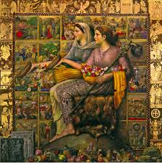 FERTILITY: EVERYTHING ON EARTH GROWS (since Persephone is back)
BY 6TH GRADERS THEODORE, MYRSINI, ANNA, PETER, DENNIS & ALEX (CLASS F2)

