Theseus and the Minotaur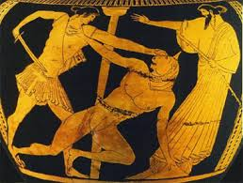

(The myth which our play will be based on)
Theseus is the great Athenian hero. His father Aegeus is king of Athens, but Theseus grows up in southern Greece with his mother. When he is old enough, Theseus travels to the city to meet his father and overcomes many obstacles along the way. By the time he reaches Athens, he is known as a hero. Not realizing that Theseus is his son, King Aegeus is about to poison him, but just in time Theseus shows him a sword that his father left for him. Aegeus declares Theseus heir to the throne and sends him on an important journey.

Aegeus recounts the tragedy of Minos, the powerful ruler of Crete, who lost his only son Androgeus while the boy was in Athens. Aegeus had sent him on an expedition to kill a dangerous bull, but it killed Androgeus, and in revenge, King Minos vowed to destroy Athens unless every year seven maidens and seven men were sent to Crete. These sacrificial youth would be fed to the Minotaur, a monster, half-bull and half-human, who lived inside a labyrinth. Theseus comes forward to be offered as one of the victims. He promises his father that he will kill the Minotaur, and upon his successful return, his ship will carry a white sail.
When the fourteen men and women arrive in Crete, they are paraded through the town. Minos's daughter Ariadne sees and instantly falls in love with Theseus. She confers with Daedalus the architect to devise a plan for her beloved to stay safe. Then she meets with Theseus, who promises to marry her if he escapes from the labyrinth. Theseus follows Ariadne's plan, walking through the maze as he lets run a ball of string so he can retrace his steps. Theseus finds the Minotaur sleeping and kills it with his bare hands. Theseus, Ariadne, and the other Athenian youth all escape to the ship going back to Athens.
On the way back, Ariadne dies. For some reason Theseus forgets to raise the white sail. His father, seeing the black sail, assumes his son has died and jumps into the sea. The sea has been called the Aegean ever since.

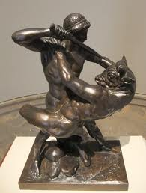Theseus fighting the Minotaur
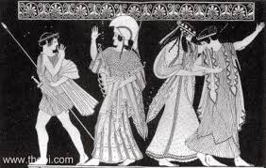
Theseus & Ariadne
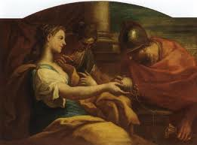Ariadne giving Theseus the ball of string to help him find the way out of the maze.
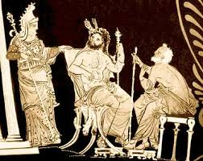 Minos, the King of Crete

By Leo, Chris, Spyros, Maliana & Lydia (F1)

