The lighthouse of Patras

Patras lighthouse (Called “Faros” in Greek) is the symbol of the city of Patras. Patras lighthouse was initially built in Saint Nickolas Pier and remained there until 1972 when it was demolished.
In 1999 the manager of the coastal zone Yiannis Dimaras decided to rebuild the lighthouse in a Southern location near Saint Andrew’s church. Today Patras lighthouse does not have a maritime usage but is a very beautiful sightseeing of Patras.
In the basement of Patras lighthouse – Faros today there is a cafe – bar – restaurant and free parking is available for visitors.
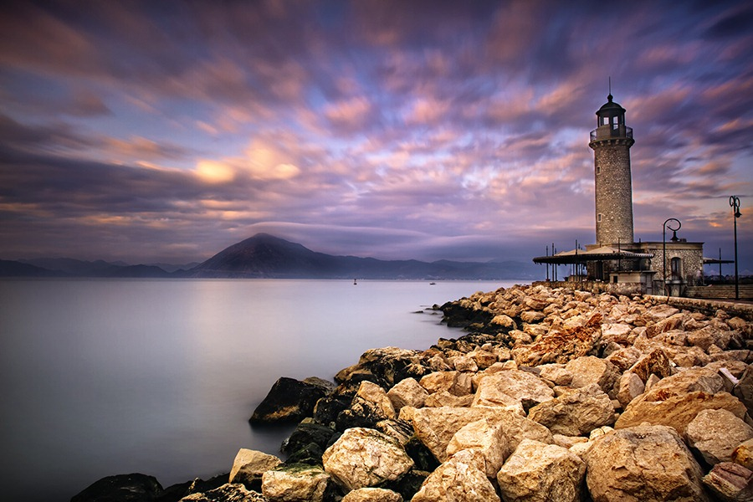

By
Angelina
Lydia
Katherine

