THE LIGHTHOUSE
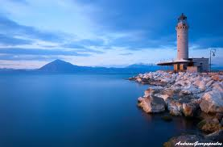

The lighthouse is the symbol of the city. It has a café underneath it with a large TV where they broadcast mostly soccer games for people to come and watch while enjoying a beverage of their choice. There is a playground right outside the café for children to play in. The café is next to the sea, so one can sit next to the windows and enjoy the waves crashing against the wall.

by Chris
