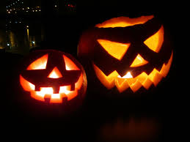
ΤΗΕ history of haloween

Halloween as it is celebrated these days is but a pale representation of its rich and multicultural history. It is not, as some would call it, a celebration of the Devil or of Hell or of the Damned, but rather a blending of the celebrations marking the end of the growing season, a heralding of the coming of the winter months and folk traditions that told of the day when the veil between the living and the dead, ever a transparent, gossamer veil at that, would lift and ghosts and ghouls would walk among the living. From those many traditions, coming to us from the Celts, the Roman rituals and even Catholic tradition, we get the stirrings of what would eventually become Halloween.
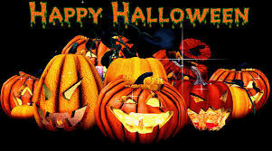
by : αngela & peter

