The 12 Labours of Hercules
- The killing of the Nemean Lion

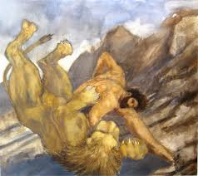
This monster of a lion had a hide was so tough that no arrow could pierce it. Hercules stunned the beast with his olive-wood club and then strangled it with his bare hands. It is said that he skinned the lion, using the lion's sharp claws, and ever after wore its hide.

- The massacre of the nine-headed Lernaean Hydra
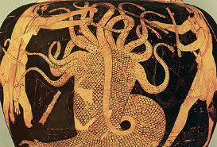
The evil, snakelike Hydra had nine heads. If one got hurt, two would grow in its place. But Hercules quickly sliced off the heads, while his charioteer, Iolaus, sealed the wounds with a torch. Hercules made his arrows poisonous by dipping them in the Hydra's blood.

- The Capture of the Golden Cerynian Hind of Artemis (deer)
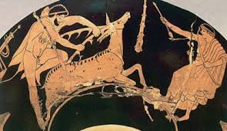
The goddess Artemis loved and protected this stubborn little deer, which had gold horns. Hercules found it a challenge to capture the delicate hind without hurting it (and making Artemis angry). After following the hind for an entire year, he safely carried it away.

- The Capture of the Erymanthian Boar
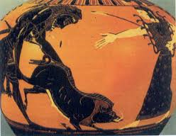
The people of Mount Erymanthus lived in fear of this deadly animal. Hercules chased the wild boar up the mountain and into a snowdrift. He then took it in a net and brought it to King Eurystheus, who was so frightened of the beast that he hid in a huge bronze jar.

- Cleaning the Augean stables in a single day
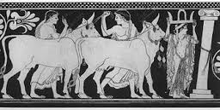
Thousands of cows lived in these stables belonging to King Augeas. They had not been cleaned in 30 years, but Hercules was told to clean them completely in a single day. To do so he made two rivers bend so that they flowed into the stables, sweeping out the filth.

- Slaying the Stymphalian Birds.
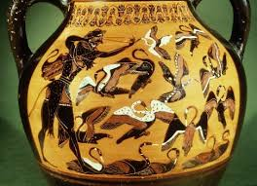
These murderous birds lived around Lake Stymphalos. Their claws and beaks were sharp as metal and their feathers flew like darts. Hercules scared them out of their nests with a rattle and then killed them with the poison arrows he had made from the Hydra's blood.

- Capturing the Cretan Bull.
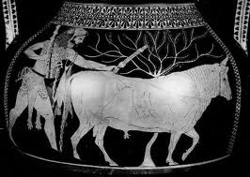
This savage bull, kept by King Minos of Crete, was said to be insane and breathe fire. Hercules wrestled the mad beast to the ground and brought it back to King Eurystheus. Unfortunately, the king set it free, and it roamed Greece, causing terror wherever it went.

- Capturing the Mares of Diomedes.
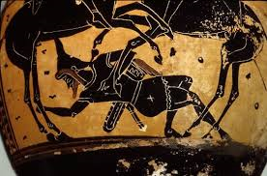
King Diomedes, leader of the Bistones, fed his bloodthirsty horses on human flesh. Hercules and his men fought and killed King Diomedes and fed the king to his horses. This made the horses tame, so that Hercules was able to lead them to King Eurystheus.

- Taking the girdle of Hippolyte, Queen of the Amazons.
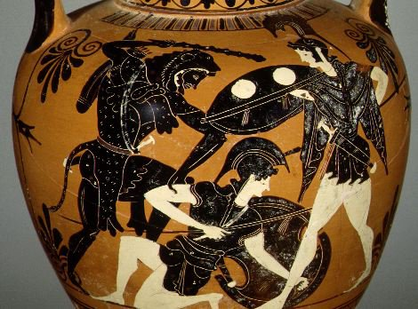

Hercules went to the land of the Amazons, where the queen welcomed him and agreed to give him her girdle for Eurystheus's daughter. But Hera spread the rumor that Hercules came as an enemy. In the end he had to conquer the Amazons and steal the golden belt.

- Capturing the cattle of the monster Geryon.
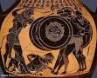
Geryon, a winged monster with three human bodies, had a herd of beautiful red cattle. He guarded his prized herd with the help of a giant and a vicious two-headed dog. Hercules killed Geryon, the giant, and the dog and brought the cattle to King Eurystheus.

- Stealing the golden apples of the Hesperides.
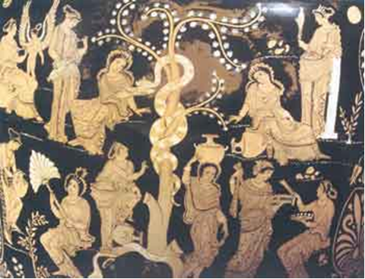
The Hesperides were nymphs. In their garden grew golden apples protected by Ladon, a dragon with a hundred heads. Hercules struck a bargain with Atlas, who held up the earth. Hercules shouldered the earth while Atlas, the nymphs' father, fetched the apples.

12. Capturing and bringing back Cerberus
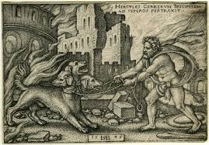
Hercules was ordered to capture Cerberus, the three-headed guard dog of the underworld, without using weapons. Hercules wrestled down the dog's wild heads, and it agreed to go with him to King Eurystheus. Cerberus was soon returned unharmed to the underworld.

BY THE 6TH GRADERS NICOL, ASPA, THENI & PANTELIA (F2 CLASS)

