E-twinning project
Talking about our school teachers

So, here is November! This month we are going to talk to you about our teachers. We have a mainstream teacher, Miss Joanna, who teaches us Language, Maths, Science, Geography, History and Religious Education. In our school, we also have two English teachers. One of them, Mrs Maria P., teaches us English. There are two teachers for P.E. too, but our P.E. teacher is Mr. Michalis K. We have also got other school subjects, such as Art with Miss Athanasia K., computers with our I.C.T. teacher Mr. Dimitris K. and French with Miss Natassa. We also learn Drama with Mrs Maria (the drama teacher), Music with Mrs Maria R. (the teacher of Music) and Social Education with our school’s head teacher. What lessons do you have at your school and who teaches them to you? 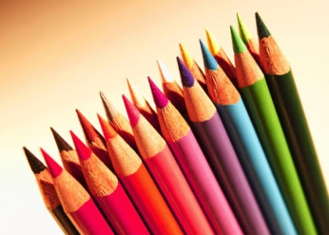 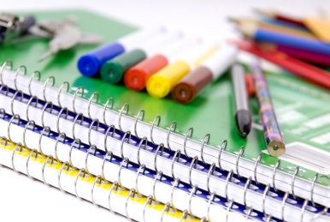 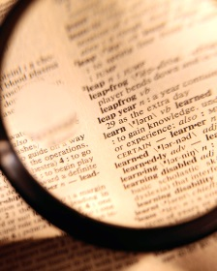
By Catherine, Demy, Athina, Poly

