2nd round

group 1
Horse and dog's adventure

(by Julia & Ania from Poland)
(By Alkis, Fanis, Anna, Nina & Christine, small-sized group from Greece)
(By Karolina , Julia and Marysia from Poland SP111)
(By Labros and George from GREECE)

Far away, on a certain farm lived a horse and a dog. They were good friends. They did everything together. They ate together, they laughed by the same jokes. But one day something happened with their friendship.........

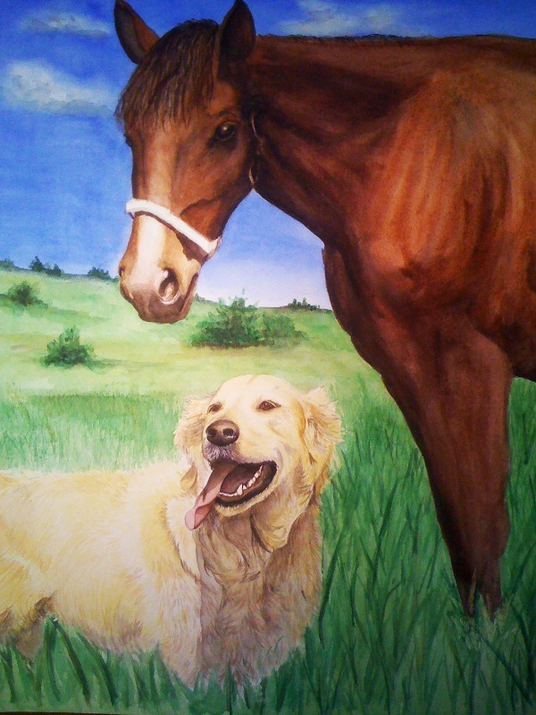

"What?" Isabel asked. Grandma said, " Their friendship was ruined by two roosters which hated the dog, because once he had eaten a little chick. The roosters lied to the two friends. The first rooster told the dog that the horse thought it was too pretty to have an ugly dog for a friend. The other rooster talked to the horse and told him the same lies. The day after that incident had happened the two friends decided to take separate paths....". "No", said grandpa, who was listening to the story. "The horse and the dog started fighting. The reason was which of the two could run faster. So they decided to participate in a race competition. 'The fastest will be the winner and the best animal on the farm', the horse said, but the dog got disappointed because he knew that the horse could run faster than him. When the dog returned home he started crying because he was sure he would lose not only the race but also his best friend. The next day...

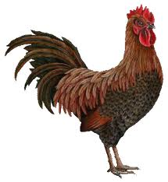

the dog got up early in the morning. "I know I’m going to lose, but wait a second, nobody said that you cannot cheat", he thought. When he reached the city he saw a shop with magic things. The dog walked towards the shop window and he saw lots of pairs of magic boots. Without thinking, he entered the store and took the shoes from the shop window. Then it put the boots on and started to run as fast as he could because the seller was chasing him. In no time he found himself running on the farm which was set 2 km away and he saw the horse and the rooster...
The dog went close and heard the chat of the animals. Then he got out of his hide and explained to the horse that he never said these words. The horse looked at the rooster angrily and kicked it. The dog and the horse became friends again. Since then nothing got between them.
The end

group 2
'Nightmare in the forest'
(by Jakub and Kuba, Poland) continued by Harry and Spyros from Greece and Karolina , Julia and Marysia from Poland SP111
Costis & George, small-sized group, Greece

One evening John and Mary were coming back from a party which was far away from their house. Unfortunately they lost their way. As they were driving through the forest, John felt that something was wrong with the steering wheel. In no time they crashed on something! Fortunately, they both were ok. John got out of the car to look for help. Mary, feeling dizzy, stayed inside the car...
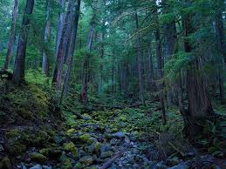

John climbed a tall tree to see if there was a village or town near there. He could see a light quite far away. He felt a little relieved! Immediately, he came back to his car to tell his friend the good news, but Mary wasn`t there. What a shock! She had just disappeared.......John saw mysterious footprints next to the car. He feared that they could be Mary’s footprints. He decided to follow them. Slowly he walked after the footprints. Next to the footprints there appeared another trace, which looked like … a pulled bag ! John fearfully started to run, always following the footprints, which led him to a cemetery….

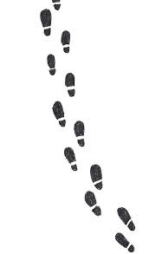

There he saw his friend's jacket. He heard an unusual noise. John started to feel dizzy…then he fell unconscious. But it did not last long. He came round and saw a big cave. He smelled something good and, following the scent, he found himself inside the cave. To his great surprise and relief he saw Mary sitting on a rock talking with some strange but sweet creatures. They asked John if he wanted to be friends and John accepted. After all this misunderstanding they all went to a beach café nearby!

tHE END

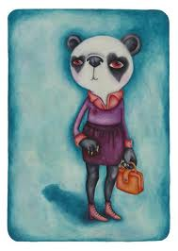

2nd round_group 3
Monika and Zuzia from Poland continued by Nefeli ,Maria ,Marilena ,Sevi and Lydia from Greece and Karolina , Julia and Marysia from Poland SP111 and Liberty & Aristotelis, small-sized group, Greece

Dangerous adventure

Far , far away lived a little princess. Her name was Diana. Her hair was black ,her eyes were blue and her eyelashes were very long and beautiful. She liked travelling and loved adventure .She always wanted to see a golden deer. One night , she heard a strange voice in her dream telling her that she could take up this adventure.

She picked up her things and called her friend Alice to go with her. In the morning they arrived in a big forest. First they had a picnic and they went for a walk . They felt happy and relaxed. In the evening the two girls set up their tent. As they were having a rest in the tent, they heard a strange noise. Hurriedly, they got out and found out that it was the gold deer. It was so amazing! They followed it silently .......
The Girls didn’t want to scare the animal. They followed after the gold deer as silently as possible. After a few minutes of following, the deer led them to a strange cave. Fearful princesses were going to stop the animal but something stopped them. It was something queer, mysterious. The Gold deer entered the cave, where there were lying…curious things on the ground.

The girls got into the cave and , to their dismay, they saw the gold deer dead! They were so sad that they started to cry. Their tears fell onto the deer but it did not move. They decided to bury it in a place nearby. The next morning they went to its grave to put some flowers. While they were laying the flowers on the grave they heard a queer noise. They looked round and they saw the gold deer again! The girls were so happy! The gold deer told them that their true tears brought it to life again!
"Well the adventure was dangerous indeed, but it was worth the trouble", the girls said..

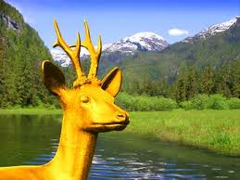
The end
group 4
"A sheep and the shepherd'

By Weronika and Ola from Poland and continued by Harry ,Pete K. ,Labros from Greece and Karolina , Julia and Marysia from Poland SP111 and Anna & Christine, small-sized group, Greece

A boy named Spooky lived in a big house with a beautiful garden. One day he heard a knock on the door.....He opened the door and: 'WOW!' - he screamed. It was a sheep. He built a tiny farm in his beautiful garden for that sheep. He gave it a name 'Stefan'. But a few months later Stefan disappeared. Spooky was very sad.........

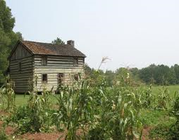

But he did `t give up .` I am going to find Stefan. I am going to try hard ` he thought. He knew that his sheep had been kidnapped and he felt a little tense. The following day he decided to go to the neighborhood to look for the sheep .While he was walking anxiously he saw something on the ground. It was the small bell which was hung on the sheep`s neck. Now he was sure that Stefan was near....

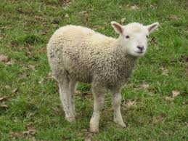

Spooky was terrified. He did not understand how anyone could treat a poor animal like this. He wanted to find his friend. He went through the area looking for Stefan. Unfortunately the sheep was in no garden. Spooky came back home feeling really cheerless. Suddenly he heard the sheep’s voice….
The sheep was an angel now. Some bad people had slaughtered it! When Spooky realized it he got desperate. As he was crying he heard a lovely, queer voice telling him, "Little Spooky, you are my best friend. I'll miss you". Then, all of a sudden the sheep appeared and hugged him. The boy very much touched started to cry but the sheep begged him not to cry and it disappeared! A few years later, when Spooky was twenty years old, he saw a beautiful sheep outside his window…
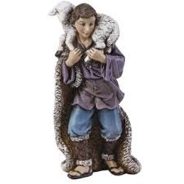

The end

group 5
Adventure at the seaside
By Marcin and Kacper from Poland continued by Giannis and Agis from Greece!!!and by Bartek, Mateusz form Poland (SP111) and Alkis & Nina, small-sized group, Greece

Last summer my friend and I went to the seaside with our families. While we were swimming in the sea, we saw a shark. The shark was very scary and terrible. We ran to the beach very fast......

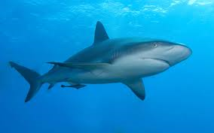
When we arrived at the beach, we started to scream ''Help ! there is a shark in the sea ! Help!" The people felt really scared and instead of helping us they ran to their cars! But only one man remained there ! It was Chuck Norris! He said ''Don`t be afraid! I will save you!'' Then he ran towards the shark and killed the shark easily ! When he came out ..................with the shark on his back everybody was cheering. They all wanted to have his autograph, so he put the shark aside and started signing. Suddenly the shark started moving and changing into something else....
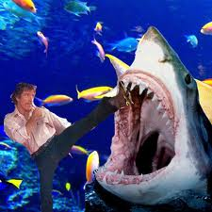

into a giant monster! He was three meters tall , he had very sharp teeth and three red eyes. The monster started screaming and terrifying the people around. All of a sudden Chuck Norris drew a shotgun and tried to kill the monster.
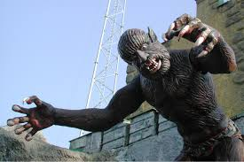
But it was a difficult target. He was chasing the monster for over 2 hours. Meanwhile the people on the seaside were scared to death and they started digging a huge hole in the sand to hide! Finally, Chuck Norris, fearless, shot the monster rapidly right in its face and the monster dropped dead. Everybody got out of the huge hole and continued their day happily!
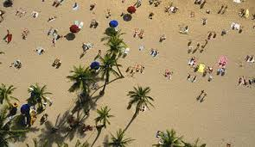
The en

group 6
"The trip to Spain"
By Piotr and Adam from Poland continued by Stelios , Kostas , Savvas and Gregory from Greece and by Mateusz and Bartek from Poland SP111 and Fanis & Eugenia, small-sized group, Greece

Three years ago I went to the airport and then I flew to Spain. First I flew through Germany and France. Next I landed in Spain.....

When I arrived I went straight to a hotel to have a rest. I felt so exhausted. The next morning I went swimming to the waterslides.

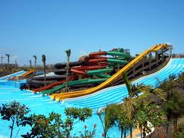

It was very beautiful! However I had an accident and I hurt my head. I felt awful! They took me to hospital immediately and they put a bandage over my head. One week later I saw a football match with Real Madrid and Barcelona...
The match between Real Madrid and FC Barcelona ended with the result of 1: 4 for FC Barcelona. When I went to the hotel I was very happy and I played with my dog Atom, who was my companion. After the accident I still felt very tired and I wanted long hours of rest. So I went to bed. Soon after I fell asleep and I dreamed that my dog was the goalkeeper of FC Barcelona...
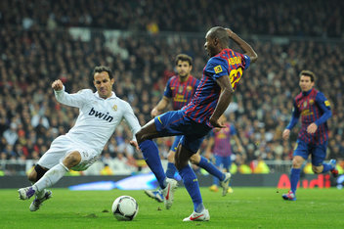

When I woke up I ate a big breakfast with ham & eggs. Later on I went to the shops to buy some souvenirs before leaving. As I was strolling through the town I noticed a wooden bird that had the word SPAIN carved on it.
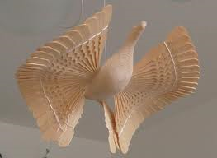

Although it was expensive I bought it because it seemed to me amazingly beautiful. Half an hour later I returned to the hotel because I had run out of money. The next day I took the plane back home. Now, three years later, whenever I see that magnificent bird I remember my trip to Spain with every detail. I wish I could go again and experience the same things, except for the accident of course!
The end

group 7
"Holidays at the seaside"
By Ola P. and Ola G from Poland
(Óscar from Spain)(Karolina , Natalia and Julia from Poland SP111) and Anna, Christine & Liberty, small sized group, Greece

One day three friends decided to go to the seaside. They stayed at a five-star hotel in Wladyslawowo in Poland. The first day they went to the beach to collect shells. They saw a man...

He was dressed but he was using sunbathing cream over the clothes!! They were surprised to see him doing those strange things. They approached him and asked who he was, then the man said, I am the man who will capture you !!!.......
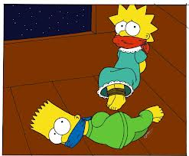
The strange man suddenly took out a big bag from his backpack and he started catching the boys. They were so scared that they couldn’t move. After a few minutes the bag was full and the strange man knotted it. The boys felt that they were dragged and then the pain they felt was caused by throwing them into the car. After twenty minutes of driving, the man took the boys out of the bag. The boys were terrified because they were in a cemetery....
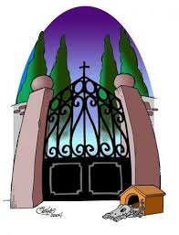
They were scared to death and they started to scream. But the man threatened them that if they didn't stop he would hurt them. Then he ordered the boys to get into the car again and he drove off. However, one person heard their voices and followed the car. When the strange man stopped to put patrol, the other person took the chance and approached the car. He set the children free and the boys were so thankful. After that, the police arrested the kidnapper. The boys returned home safe and sound.
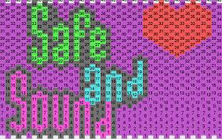

The end

group 8

The adventure with a snake"
By Patrycja and Kasia from Poland continued by Panos and George from Greece and Karolina , Julia and Natalia from Poland - SP111 and Christine & Anna, small-sized group, Greece

Last week my brother and I went to the forest. First we went for a walk. As we were walking along the forest paths, we saw a snake! I was so terrified that I did not move. So the snake bit me and I began to shout .

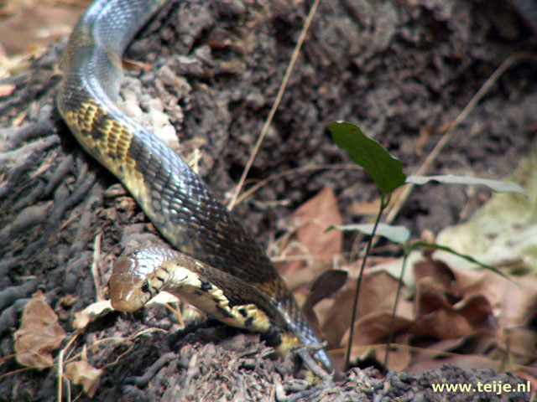

I felt really horrible! It was as if I was about to die. I could not move and I did not know what to do. I was trying to look around for help when suddenly I saw an ugly, vicious man with a saw in his hand ` Am I seeing a ghost ?` I said to myself .........

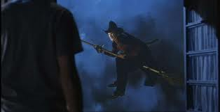
...I asked my brother if he also saw the man with the saw in his hand. He said he could see nothing. Suddenly the man began to approach me. I was terribly afraid. I grabbed my brother and hugged him tightly. He said he was with me. Next, I couldn't hear anything because my head ached awfully. The scary man came closer and …

.. …Being in a real nightmare I felt that fearful man snatching me. I was petrified and I lost my consciousness. When I woke up I found myself in hospital. My dearest family was around me. I felt so relieved! Then I asked my brother if he had seen that horrible man but he answered negatively. Well, this is a mystery, isn't it?

The end

