1st round

GROUP 1
AN UNFORGETTABLE PARTY!

( By Sevi , Nefeli ,Lydia , Maria ,Marilena from Greece )
(cont. by Karolina, Julia, Natalia, Wiktoria, Bartek from Poland)
(by Weronika from Poland) (Ivan, Adrian and Annas from Spain)

Last summer Alice decided to have a party at the beautiful beach near her house. She had prepared everything and she was very excited about it. She went to the beach an hour before the party. For a long time she was checking if everything was on its place. Then, the time of the party came. Alice sat on a little pier, soaking feet in the water, waiting for her guests to come. After another hour she felt a bit anxious because nobody came. Suddenly everything became clear! She forgot to send the invitations! She ran to her house quickly to check if they were still in the cupboard in her living room. She was just running through the hall when she heard knocking on the front door….She came up to the door and opened it. She looked around but nobody was there. Suddenly she heard something squeaking. She saw a little, wide-eyed bat on the ground. She picked it up carefully and said "you are my only guest today - I think.
But she wasn't right.

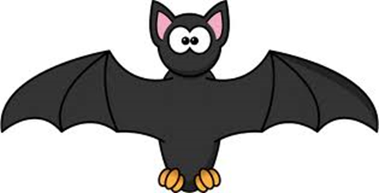

She came back inside and looked for a small box to leave the bat inside. While she was doing so, there was another knock on the door. She ran to the door, she opened it and found a tall, strong, mysterious man. "Have you found my pet?" he said with a low horrible voice. "It´s a small bat". "Yes- Alice said- I think it´s hurt".
"Well, if you don´t mind I want to help it recover " he said. "It ´s important for me and my friends".
"Your friends?" Alice asked. "Yes. Come in guys, Bernie is here" he shouted. And then dozens of dark figures came out of the night towards Alice´s house. She couldn´t believe it! Vampires, wolves, witches, zombies and all kind of monsters !!! They were just about to enter the house!! Alice shouted and fainted.
Another knock on the door... Alice opened her eyes. What was happening? Where were all the monsters?.
Another knock on the door... "Alice, are you in? We are all here for the party. Come on, Alice... It´s me. Sarah... and Peter, Susan... All your friends. Come on.... Open the door..."
Alice realized she had been sleeping and everything had been a dream. She opened the door and all her friends were there waiting for the party. They came inside and the party began.
But when Alice went into the kitchen for more popcorn.... she found the small bat sleeping in the box....
The end

GROUP 2
" An island adventure "
( By Savvas , Pelopidas ,Stelios ,Kostas ,Gregory from Greece )
(cont. by Marysia, Szymon, Maks, Mateusz, Artur from Poland)
Monika from Poland ( Carlos and Ismael from Spain)

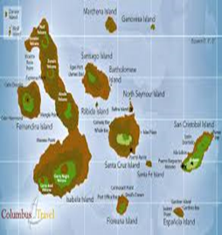
One hot summer's day on the Galapagos islands we were at the beach. We were drinking cocktails and having fun . While we were sitting on the beach we heard a strange noise .We felt really anxious...but we decided to check it out. We took our backpacks and (we) went in the direction of the sound. We reached a dark cave near a big mountain and the sound stopped. We switched our flashlights on and we saw different things lying on the floor: clothes, backpacks and some food. We got a little scared but we wanted to know who had left those things. We went deeper to the cave and we saw a little lake at the end of it. We put on our diving equipment (thank God we had taken it!) and we jumped into underwater corridor. After a few minutes we reached the surface on the other side of the cave. We were really surprised by what we saw there…

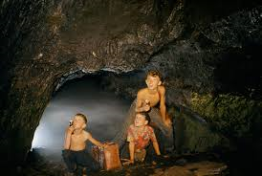

On the ground there was a huge nest with egg-shells in it. We wondered whose they were. We came closer. Around the nest there were footprints. Those footprints were much bigger than ours. We wanted to find out where they were leading to, so we went along their path.

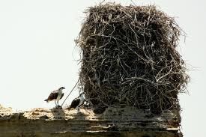

After a ten- minute walk along the tunnel of the cave, we found an enormous cascade at the end. We crossed (through) it and what we saw on the other side was amazing: there was a beautiful garden, the most beautiful garden we had ever seen!!!. All kind of flowers, plants and trees grew everywhere. We were astonished!!!. Strange animals were walking or flying around: blue squirrels, foxes with pink wings, golden snakes with six legs... It was a breathtaking different world! We decided to explore it carefully before coming back home. We would have a lot to tell on our way back!

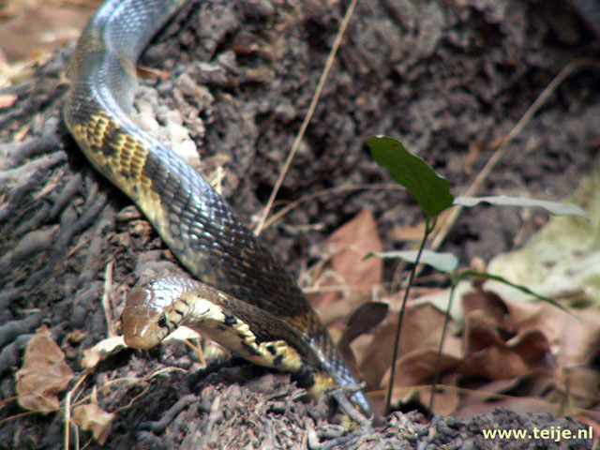

After a few days we went back home and informed the authorities. But when a scientific expedition went there, they couldn´t find any garden...

The end

GROUP 3
AN ADVENTURE
(by Nick, Thymios, Peter and Spyros from Greece)
(cont. by Piotr from Poland)
(by Weronka & Ola from Poland) (Gema, Andrea and Fatima form Spain)
A poor boy named Lee moved to China. He was really poor and very sad, but he knew Kung-Fu perfectly. One day he managed to find a job in his uncle's restaurant. Now he was very happy but he didn't know that his enemies were "waiting" for him.

The time was passing by and young Lee was proud that he finally found his place on Earth. He had a job, a family and a girlfriend - Youkomi. One day he got a message. It turned out that he inherited a big villa after his uncle. Everything seemed to be fine, but one afternoon he came back from work and he couldn't find his girlfriend. Youkomi was kidnapped...Lee wondered: 'Where is Youkomi?' Finally he decided: 'I have to go to that empty storehouse, maybe there will be some clues'. After a ten -minute drive Lee was there. He saw a thick rope and footprints. He knew now that she had to be there........
He looked around and he saw a dark shadow running on one side of the building. He went right there and found Youkomi sitting on a chair in the middle of the room. She was strongly tied and gagged. Suddenly, 4 men jumped into the room from an upper floor. Lee moved quickly and, using his wonderful kung-fu techniques defeated the four men. He rescued Youkomi and they run to the Police Station. There Lee discovered that Youkomi was a rich young heiress and those men wanted money from her father.
Soon after they got married and they lived happily forever.

GROUP 4
THE SISTERS
(by Irene, Demetra, Ellie and Giota from Greece)
(cont. by Michał form Poland)
by Monika & Zuzia from Poland) (Oscar and Jorge from Spain)
Once upon a time there was a girl, Eliza, who lived in a palace as her family was very rich. Eliza was very beautiful, but she wasn't clever at all. She had a sister, Maggie, that was really brainy but very ugly. The sisters did not like each other. All the people who knew the sisters loved and admired the ugly one, because of her intelligence. Eliza could feel it and was extremely unhappy and jealous.

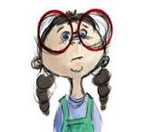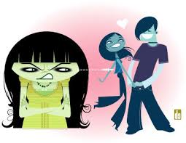
One day Eliza thought: "I can tell Maggie, that I'm going to invite her to a party at the cliffs. When she is there, I'm going to give her a sleeping potion as a drink". A few days later the time for the party came. People from the whole city came to the cliffs to dance, eat and drink. It was time for Eliza's plan to begin...When all people were talking and having fun, the sisters went away to a weird place. Maggie didn't know what her sister was planning to do. Eliza gave her sister some drink in a small bottle and she ordered her to drink it. Firstly Maggie was confused a little bit. Why had Eliza brought her around this place, why couldn't they stay at the cliffs? Finally Maggie drank and fainted. She was about to fall from the cliffs into the deep sea, but in the very last moment a young man appeared riding a horse, took her and saved her from falling.
Eliza was arrested and sent to prison. Maggie and the young man became friends and later they fell in love with each other, because he thought that Maggie was beautiful inside and outside.
The end

GROUP 5
THE DESERT ISLAND
(by John, Agis and Faidon from Greece)
(cont. by Szymon, Michał, Sebastian and Alek from Poland)
Patrycja from Poland and Fanis & Aris, small-sized group, Greece
One day my friends faidon, Agis and I went surfing. Suddenly, as we were surfing, a huge wave covered us and threw us on a desert island. We fell asleep for a long time and when we woke up, we saw a native...citizen of the island.

He took us to his village and gave us fresh fruit and coconut milk. Around the village there were lots of wild animals. We decided to go on a trip and then...we saw a lion. We were very scared. I began to shout and the lion ran towards me. Suddenly I saw a tall tree. I started....

climbing on it hurriedly because I was afraid. While the others were trying to put on a fire I was giving them some little branches to help them since I couldn't do anything else. A few minutes later they managed to light a fire and scared the lion away. As the hours passed by we tried to find the beach so we could make a float from all the sticks we had collected. Finally we were able to find the beach and make a nice float : Now the only problem is that we don't know where to go since we don't have a compass, but I am sure that we'll find our way someday…
The end

GROUP 7
THE TWO FRIENDS
(by Pete, Harry and Lambros from Greece)
(cont. by Michał form Poland)
Ania and Julia from Poland (Alex and Gema from Spain)

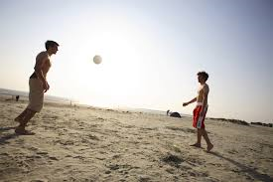

A sunny day Petros and Andrew, two good friends, went to the beach. The weather was wonderful so they decided to play beach volleyball. Petros took the ball and passed it to Andrew, but suddenly Andrew fell down. What was going on? Petros was terrified...
Andrew was not responding to Petros' words. He was lying on the sand, and his eyes were closed. Petros called an ambulance. When they were at the hospital, the doctors told Petros that Andrew had some kind of liver malfunction, which activated itself when they were playing volleyball. Some hours later, Petros was crying in his room. He was sure that nothing can save his friend now. And as he was thinking all this the doctor called him, and told him about…

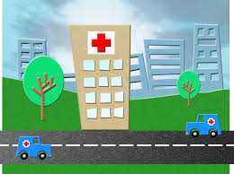

an operation. Petros could be a donor. At first he was very happy. But later he became anxious and scared, 'What will happen with me after this operation?' - he thought. He was also starting to feel bad as he thought that he was not a good friend, because he did not want to be a donor. He went to hospital to see Andrew, to explain to him that he couldn't be a donor, but when he was arrived there a nurse told him that his friend was being operated, because they had found another donor. Petros was really happy and relieved , although he felt that he was not a very good friend. When Andrew recovered from the operation, Petros told Andrew the whole story. Andrew wasn´t angry with Petros, he knew that it had been a very difficult decision although he was sure that Petros would have helped him if everything had gone wrong.
After a few weeks they were playing on the beach again.
The end

GROUP 8
THE EVIL CUPCAKES
(by Fanis, Anna, Christine, Alkis and Nina from Greece)
(cont. by Michał from Poland)
by Jakub from Poland (Jorge, Oscar and Alex from Spain)
Once upon a time there was a baker, called Mr. Fox. Everybody laughed at him. One day he decided to take revenge and while he was thinking he came up with a fabulous idea. He made a poison and put it in the cupcakes. When a customer, who was always making fun of the baker, entered the bakery, Mr Fox gave him a cupcake to taste. When the customer ate the cupcake...

(at first) nothing really happened. Mr. Fox was selling the cupcakes to all people that laughed at him, and everybody liked the cakes very much. After some time he was so rich, that he could sleep on his dollars. It was time for the second part of the revenge. It was time for the...zombie plague!...People started to change their look and behaviour. Mr Fox noticed that something was happening to his customers. Something really strange started to happen during the night. Mr. Fox could hear weird voices downstairs. One night he dared to see what was going on there. He was going downstairs very quietly and suddenly he saw...

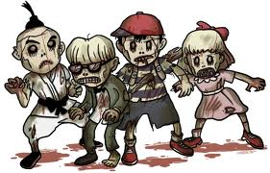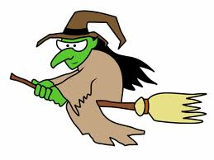

more than 20 zombies eating all the cupcakes anxiously!! So the evil cupcakes not only transformed people into zombies but they were also addictive!! In a few days the whole city was a zombie city and he had to make thousands and thousands of evil cupcakes to keep the zombies busy. Mr. Fox didn´t know what to do. He thought that not poisoned blood would recover people again, so he used his own blood and put it inside the evil cupcakes he made that night. The next morning all the zombies were normal people again. Mr. Fox burnt the evil recipe and he only made chocolate and strawberry cupcakes since then!!
The end

