3rd round_

group1
"THE LOST DOG"
(by Karolina, Natalia and Marysia from Poland - SP 111 Lodz) (continued by Irene, Ellie and Demy from Greece)
(by Anna,Christine and Nina from Greece _small sized group), by Kasia & Marcin from Poland
One day Isabel was walking in the park. She was used to having a walk every Saturday because she liked the park very much. Suddenly, she saw a small, brown dog between the trees. She came near it but… it ran away. Isabel started chasing the dog. She stopped when the dog ran into an old, scary, deserted house...
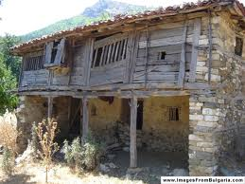

She was very scared and she did not know what to do, «Shall I open the door?» she asked herself. She felt so nervous! After a few minutes she decided to go in. Isabel opened the door quietly but when she came in she saw a dark and big…rat.

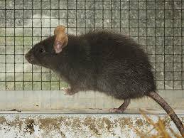

The rat was mute because of the scientist who had given him pesticides. Isabel kissed the rat and so it turned into… a handsome prince!

Then she and the prince went to look for the dog. As they were searching in the huge park, a big monster appeared out of nowhere! Isabel and the prince were so scared but then a fairy......arrived to help them. She said some magic words and she rescued them. Then the lost dog appeared. After that they all came back to her house. Isabel along with the fairy helped the prince restore his voice and come back to real life and they became best friends.

3rd round_group2
"IN THE MOUNTAINS"
(by Karolina, Natalia and Marysia from Poland - SP 111 Lodz)(continued by Pete K. ,Panos T., Labros and Harry, Greece) (continued by Fanis and Alkis-small-sized group, Greece) by Zuzia & Victoria from Poland
One day Martin went on a trip up in the mountains with his school friends. He used to go up to these mountains with his parents almost every year, when he was little. He knew all the tracks and passes. The kids were in the middle of the path to the mountain top.

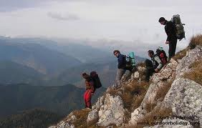

Suddenly someone pushed Martin by accident and the boy fell on the rocks...
Fortunately his parents had given him their mobile phone in case of emergency. He felt relieved when he found his phone in his backpack! He called the police immediately and told them where he was. His friends had not noticed that Martin had fallen and they continued trekking. Martin waited and waited but the police did not arrive. One hour later he heard something from…
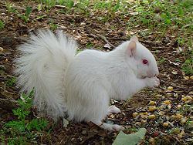
the forest nearby. He turned around and saw the bushes moving, but he got relieved because it was just a squirrel. After a few minutes he saw many squirrels coming towards him. They were really friendly and tried to help Martin, but they couldn't do it since he was very heavy. When the police arrived at last…
Martin was not in the place he had pointed. He was kidnapped by the squirrels! They wanted to have a human for themselves! They chose Martin because he was helpless.
The police found some clues and they thought they could be Martin's footsteps. So they followed them and found out that Martin was hidden in a tree house.
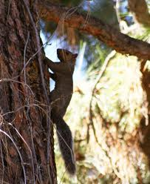
He was hurt and terrified. The policemen took him to the police car but the squirrels got really furious.

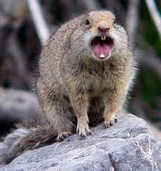

They ran after the car but when they reached the city centre the squirrels decided to go back to the forest. Martin was taken to hospital. In a few days he returned home safe and sound. Of course he never visited the mountains again!

3rd round_group3
"IN THE JUNGLE"
(by Karolina, Natalia and Marysia from Poland - SP 111 Lodz) (continued by Giota from Greece), (by Anna and Christine from Greece), by Martin & Pola from Poland
During the holidays Caroline went to an exotic camp in South America. It was in the middle of the jungle.
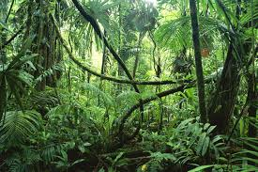
One day she woke up very early and she went out of her tent. She saw a beautiful, colorful parrot and she went after it. The parrot was flying from tree to tree deep in the jungle. After walking for half an hour Caroline saw she was all alone and the parrot had flown away. So she hurried back to the camp....
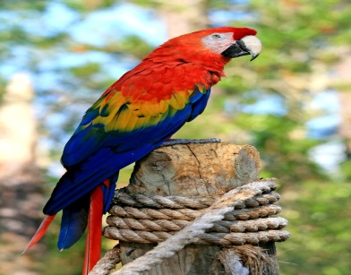

The following day Caroline got out of her tent and went for a walk in the jungle. While she was walking she saw an angry lion. When the lion noticed her it started chasing her. Caroline was very afraid. But suddenly the parrot appeared and it scared the lion away. The parrot saved Caroline........
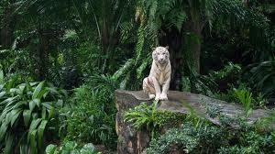
Then the parrot sat on her arm, and together they went to her tent. The next morning, when Caroline woke up, she saw that the parrot wasn’t there. So she tried to find him. During her search, deep in the jungle, she saw a big tiger and she got scared to death…
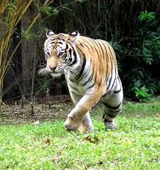
But the parrot which appeared out of nowhere saved her again. Caroline took the parrot with her and they became best friends. Since then they are together and no one can ever touch Caroline!

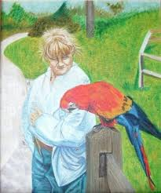

3rd round_group4
"THE FISHERMAN"
(by Wiktoria, Julia and Szymon from Poland - SP 111 Lodz)
cont. by Alkis & Nina, small -sized group, Greece), by Monica, Kuba, Malwina & Ania from Poland

Last summer an old fisherman, Henry, sailed in his boat to the deep sea. The weather was beautiful; the morning was calm and warm. Henry casted his fishing rod and waited. He was waiting for a long time but nothing happened. "It's not my lucky day" - he thought. Suddenly something started pulling the fishing line very fast. Henry tried to stop it but he fell into the water...
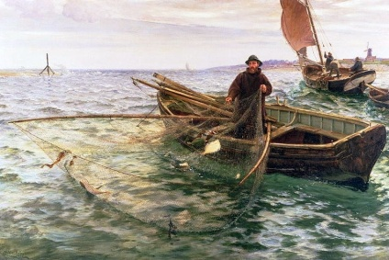

A mermaid pulled him in her cave down the water because she was used to eating fishermen. While she was preparing her plan, she remembered her grandfather who was only a real human being. He looked alike Henry. Henry was nervous about his life, so he started asking her some personal questions. He was curious to learn about her past. With her answers he understood that he was her real grandfather…
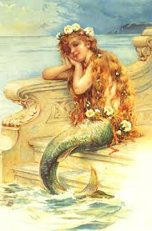

He wanted the mermaid to live on the ground with him and she wanted him to live underwater with her. They were arguing about it because they did not know how to solve this problem. At the end they realized that it would be a good idea if they spent six months in her grandfather's village and six months underwater. They tried to do so and they lived happily ever after.

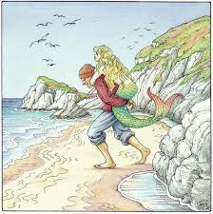

3RD ROUND-GROUP 5
"IN THE JUNGLE"
(by Wiktoria, Julia and Szymon from Poland - SP 111 Lodz)
(cont. by Christine & Anna. small-sized group, from Greece), Weronica &Monika from Poland
In a wooden cottage in the jungle there lived a scientist. He used to have a walk every day at six o'clock in the morning. He liked watching the sun rising and watching the birds. He was a bird specialist. One day he heard his favourite bird singing. He started running in its direction but suddenly he stumbled on a stone and fell into a cave...

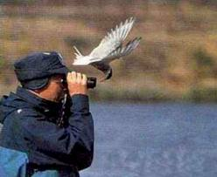
When he fell into the cave he saw skeletons of people. He was so scared when he saw them that he felt nausea. Suddenly a big bird appeared out of nowhere. The bird looked like a mythical creature, named “Polyphemus”. The creature used to eat people. The scientist was terrified but also excited. Thankfully, he had a digital camera with him and he took pictures of this creature. But “Polyphemus”, the bird, became so furious that decided to attack him…….

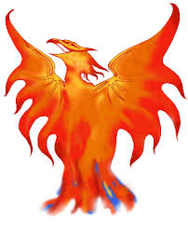
The scientist had to start fighting with this creature. But he didn't have any chances to win it. Suddenly he saw a lot of birds coming into that cave. They started to attack this creature, some of them caught the scientist's shirt and flew it up in the air. Eventually, the scientist was safe but unfortunately he dropped his camera, and now he couldn't prove he had seen this creature.

3rd round_group6
"On holiday”
(by Karolina , Natalia and Julia from Poland SP111)
(by Nina , Fanis and Alkis, small-sized group from Greece), Kuba & Zozef from Poland)
One day the three friends, Natalia, Julia and Caroline went on holiday to the sea side. On the first day the girls went to the beach, of course. They took their diving equipment, because they all loved to swim and dive. At Natalia’s signal they all plunged into the water. When they were underwater they looked around and in the distance they suddenly saw...

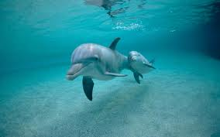

a dolphin swimming hurriedly like something was chasing it. They got out of the sea since they thought a big shark was nearby. After a while they realized that there were two dolphins that were just playing. Because they knew dolphins were extremely friendly to people, they got into the sea again and...

a shark appeared. It was going round them. They were terrified, They didn't know what to do. Finally they heard a helicopter and they started waving their hands. Thankfully, the pilot located them and signaled to a nearby ship to sail towards the kids for help. A few minutes later they were on the ship safe and sound. They learned from the captain that this shark was very dangerous, but nothing wrong happened to them!

3rd round_group7
"The lost waterfall"
(by Bartek, Szymon and Mateusz from Poland SP111)
by Faidon & gregory from Greece
Fanis & Alkis, small-sized group, Greece, Ania & Julia from Poland
One day I went on a trip with my friends Bartek and Simon. After a few hours of marching we saw that we had forgotten to take the bag with food and water. It started to get late so we pitched a tent and went to find some food. On the way we saw a waterfall. Bartek decided to go fishing, so Simon and I went over to the waterfall. After a while, on the top of the waterfall, Simon slipped and fell into the water. Quickly I ran to Bartek to ask him to help me pull Simon out of the water. All of a sudden ...

a strange man appeared and the boys got really scared. He was wearing a black mask and was holding an arrow. "What a nightmare!"! the boys exclaimed, and the man pointed at Simon. Fortunately he missed his target and the children started running as fast as they could...

but the man was fast enough to catch up with them very quickly without getting tired at all. Then the masked man managed to shoot them again and it was a narrow escape for Simon since the arrow went very close to his arm…
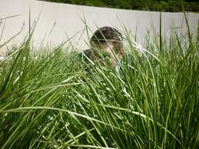
A few minutes later, while the kids were running, they saw some bushes and hid behind them without the man noticing. Finally the man continued running and the kids escaped easily.
OR (another ending)
He was chasing them through the forest. But the boys were faster. Finally they found a house in the forest, they run quickly there and they hid in the wardrobe. They were very quiet, they heard footsteps and they woke up. It was a nightmare, but was it really? Everyone had the same dream!!!

The end

3rd round- group 8
Trip to the desert island"
(by Max and Artur form Poland SP111)
(by Anna and Christine, small-sized group from Greece), by Jakub & Michal from Poland
One day Artur and I (Max) went together with our class on a trip on a desert island. We heard strange sounds reaching the deep inside of the island. We were so interested to find out what it was that we didn't even tell our teacher that we were leaving the group. After an hour of walking we met some weird people. When they realized that we were peeping at them they started chasing us....

Those strange people had a gun. The first person, shot in the air to scare us. We got scared to death! Luckily, the two people lost our traces because we managed to hide behind a tree. Therefore they thought that we went away so they stopped chasing us. After a few seconds we saw them lifting a box. Inside the box we heard some noises. In the box there was a person! Then, we went to tell our teacher that those people were criminals..........

who had escaped from prison. He went with us to see those people. We took some photos to prove that we were right. We called the police. Quickly they arrived at the place and arrested the criminals. The most exciting thing of the whole adventure was that our school received a reward for catching very dangerous criminals!!!

.

