Saint Andrew cathedral
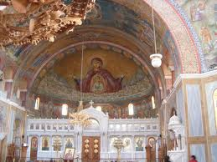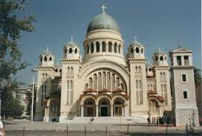

(by Spyros, 5th grade, E1)
Saint Andrew (Agios Andreas, Άγιος Ανδρέας in Greek) is a Greek Orthodox Basilica ( Byzantine Style) in the east side of the city of Patras. Along with the old church of St. Andrew (built on 1843) it constitutes a place of pilgrimage for Christians from all over the world. It is dedicated to the First-called Apostle of Christ, Saint Andrew. Construction of the church, began in 1908 but it was inaugurated 64 years later, in 1974. It is the largest church in Greece and the third largest Byzantine-style church in the Balkans. Over the central dome there is a 5 meter long gold plated cross and over the other domes there are 12 smaller crosses. These crosses symbolize Jesus and His apostles. The interior of the church is decorated with marvelous byzantine style wall paintings and mosaics.
