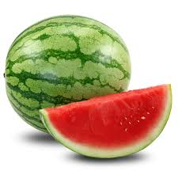watermelon=καρπούζι (karpouzi)
I like watermelon

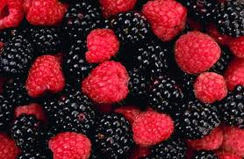berries=βατομουρα (vatomoura)
My brother doesn’t like eating berries
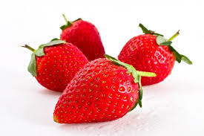strawberries=φράουλα(fraoula)
I eat strawberries in summer

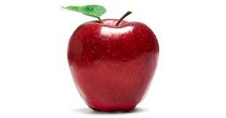apple=μηλο(milo)
Apple is very healthy

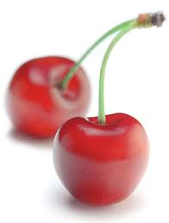cherries=κερασια(kerasia)
I don’t like eatting cherries
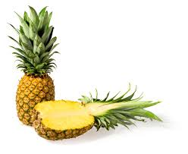pineapple=ανανάς(ananas)]
My sister likes eatting pineapple very much
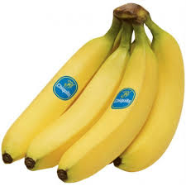banana=μπανάνα(banana)
Monkeys likes eating bananas
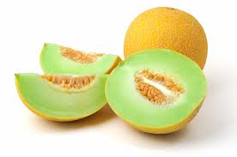melon= πεπόνι (peponi)
My mother likes melons

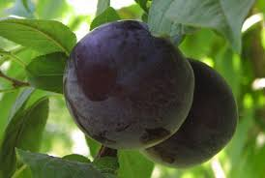plum=δαμάσκηνο(damaskino)
Many people like eating plums
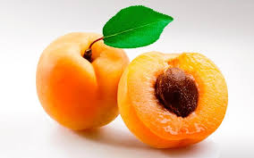apricot=βερίκοκο(berikoko)
Apricot is very tasty

