SHORT HISTORY OF ENGLAND

The earliest known evidence of human presence in the area now known as England was that of Homo antecessor, dating to approximately 780,000 years ago. The oldest proto-human bones discovered in England date from 500,000 years ago. Modern humans are known to have first inhabited the area during the Upper Paleolithic period, though permanent settlements were only established within the last 6,000 years.

ONE GREAT WRITER

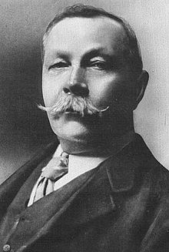
Sir Arthur Ignatius Conan Doyle is one of the most famous English writers. DL (22 May 1859 – 7 July 1930.Most noted for his stories about the detective Sherlock Holmes, generally considered milestones in the field of crime fiction, and for the adventures of Professor Challenger. He was a prolific writer whose other works include fantasy and science fiction stories, plays, romances, poetry, non-fiction and historical novels.

GOODBYE

PANOS & THODORIS

