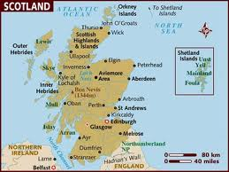
SCOTLAND
Scotland is located on the North of Great Britain.
BORDERS
South: England, East: North Sea, Northwest: Atlantic Ocean,
Southwest: North Channel & Irish Sea
CAPITAL CITY:
Edinburgh (it is the second largest city, one of the biggest commercial centers of Europe). It is situated Southeast of Scotland and its population is around 495,360 people.

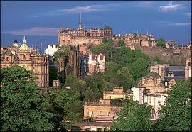
Edinburgh is also a well-known for its University as well as its annual festival.
Old and New town of Edinburgh: A UNESCO World Heritage site.

OTHER IMPORTANT CITIES:
Glasgow: Scotland's largest city.
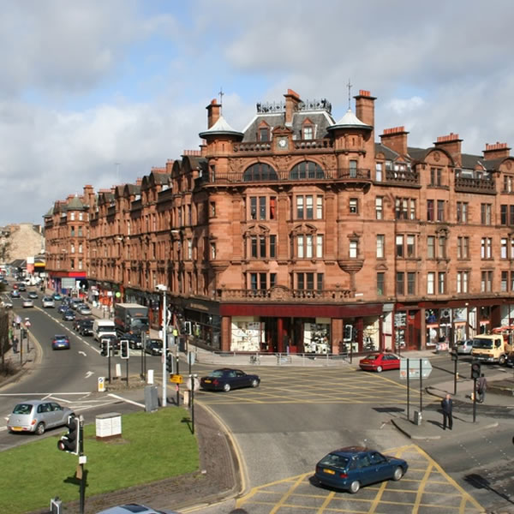

Inverness: The capital of the Highlands of Scotland.
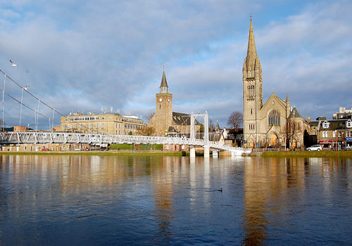

OFFICIAL LANGUAGE: English
Other official languages: Scottish, Gaelic, Scots

POPULATION: 5,254,800
CURRENCY: Pound sterling

EARLY HISTORY: First houses appeared 9500 years ago.
First villages about 6000 years ago.

IMPORTANT HISTORICAL DATE:
On May 1st 1707, Scotland became part of the United Kingdom.

LEGAL SYSTEM, EDUCATIONAL AND RELIGIOUS INSTITUTIONS
Scotland's legal, educational and religious systems are
different from those in England, Wales and Northern Ireland,
that's why it keeps its Scottish culture and national identity
alive.

THE FLAG (16th century)
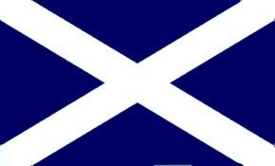
Scotland's flag is known as the Cross of Saint Andrew ( or Saltire).

NATIONAL FLOWER:
It's national flower is the Thistle. 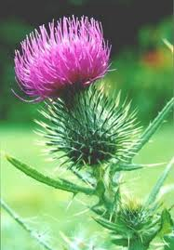

DISTILLERIES:

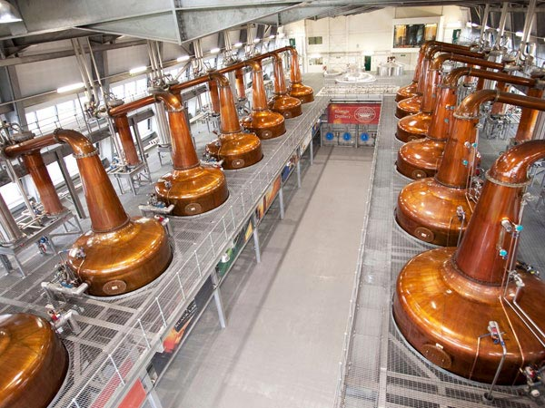

It's national drink is WHISKY. There over 100 distilleries in Scotland.

SPORTS:
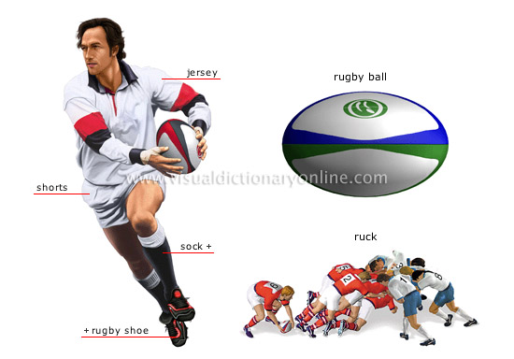

Golf, rugby, tennis and hockey.

(By the pupils of the 5th grade of the Model Experimental Primary school of Patras)

