SAINT ANDREW'S CATHEDRAL
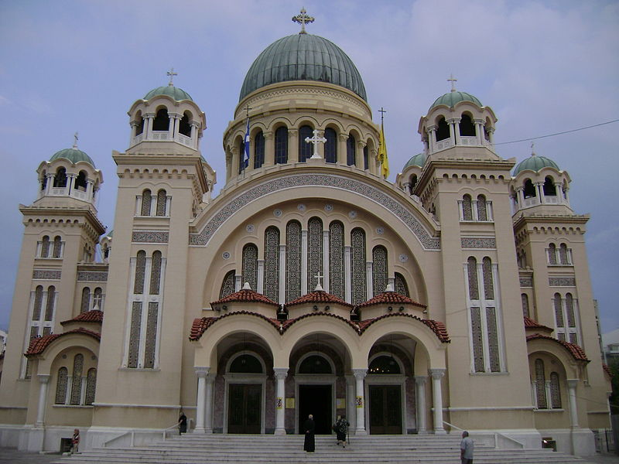
Saint Andrew (Agios Andreas) is a Greek Orthodox basilica in the east side of the city of Patras in Greece. Along with the old church of St. Andrew (which lies in a close distance) it constitutes a place of pilgrimage for Christians from all over the world.It is dedicated to the First-called Apostle of Christ, Saint Andrew. Construction of the church, of Greek Byzantine style, began in 1908 under the supervision of the architect Anastasios Metaxas, followed by Georgios Nomikos. It was inaugurated 64 years later, in 1974. It covers approximately 1,800 square meters[1] (some other sources say 2,000). It is the largest church in Greece and the third largest Byzantine-style church in the Balkans, after the Cathedral of Saint Sava in Belgrade and Alexander Nevsky Cathedral in Sofia. Over the central dome there is a 5- meter- long gold plated cross and over the other domes there are 12 smaller crosses. These crosses symbolise Jesus and His apostles. The interior of the church is decorated with marvelous Byzantine style wall paintings and mosaics.
BY PHILIP AND MARIOS

