THE RION-ANTIRION BRIDGE

Its official name is the Charilaos Trikoupis Bridge. Charilaos Trikoupis was a 19th-century Greek Prime Minister who suggested the idea of building a bridge between Rio and Antirrio. The project was too expensive at the time, when Greece was trying to get a late start in the Industrial revolution
The 2,880 m (9,449 ft) long bridge (approximately 1.8 miles) dramatically improves access to and from the Peloponnese, which could previously be reached only by ferry or via the Isthmus (Gulf) of Corinth in the east. Its width is 28 m (92 ft) — it has two vehicle lanes per direction, an emergency lane and a pedestrian walkway. Its five-span four-pylon cable-stayed portion of length 2,252 m (7,388 ft) is the world's second longest cable-stayed deck; only the deck of the Millau Viaduct in southern France is longer at 2,460 m (8,071 ft). However, as the latter is also supported by bearings at the pylons apart from cable stays, the Rio–Antirrio bridge deck might be considered the longest cable-stayed "suspended" deck.

The bridge was inaugurated on August 7, 2004, a week before the opening of the
The total cost of the bridge was about € 630,000,000, funded by Greek state funds, the consortium and loans by the European Investment Bank.
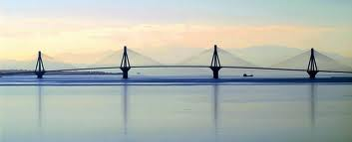
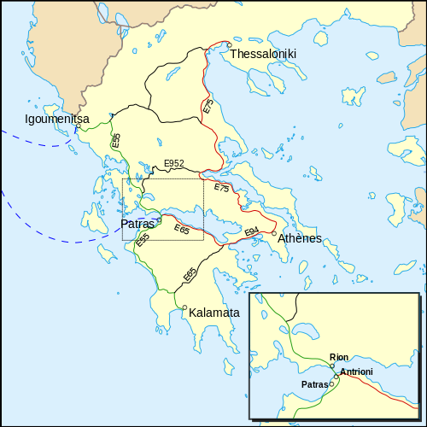

By Anna

