POPULATION

The population (in 2011:53,012,456 people)
- Male: 26,069,148
- Female: 26,943,308
- Total: 53,012,456
CAPITAL CITY
London is the capital city of England and the United Kingdom, and the largest city, urban zone and metropolitan area in the United Kingdom, and the European Union by most measures. Located on the River Thames, London has been a major settlement for two millennia, its history going back to its founding by the Romans, who named it Londinium .
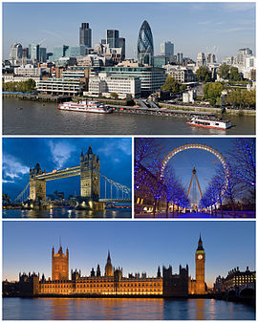
BY NIKOLETA & ASPA

