# **The little mouse**

Reporter: Hello, my name is John. I am a reporter for the BBC. Hello, what’s your name?

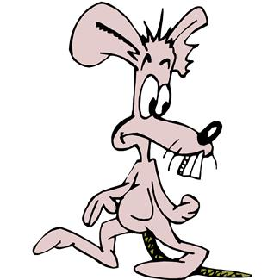Lion: My name is Leo, Leo the Lion.

Reporter: Are you strong?

Lion: Yes, I am.

Reporter: Are you fast?

Lion: Yes, I am.

Reporter: Are you brave?

Lion: Yes, I am.

Reporter: Thank you. Hello, what’s your name?

Kangaroo: My name is Carol, Carol the kangaroo.

Reporter: Are you hungry?

Kangaroo: No, I am not.

Reporter: Are you tired?

Kangaroo: Aaaaaaaaahhhhhhhhhh (*Yawning).* Yes, I am.

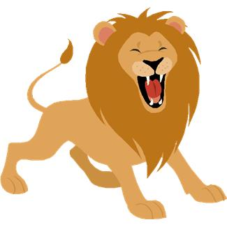Reporter: Thank you. Hello, what’s you name?

Mouse: My name is Minnie, Minnie the mouse.

Reporter: Are you fast?

Mouse: No, I’m not.

Reporter: Are you strong?

Mouse: No, I’m not.

Reporter: Are you brave?

Mouse: No, I’m not.

Reporter,Lion,Kangaroo: Ha, ha, ha. Ok, you are not fast, you are not strong and you are not

brave.

Mouse: No. But…

Reporter,Lion,Kangaroo: Yes?

Mouse: Grrrrrrhhh!!!!!!!!!!!!!!

Reporter,Lion,Kangaroo: Ahhhhh!!!*(The lion, the Kangaroo and the reporter all run)*

Mouse: I am ***very*** loud. Goodbye:

**The Hungry Pirate**

1. Pirate .............................
2. Mermaid .............................
3. Shark .............................
4. Jellyfish .............................
5. Turtle .............................
6. Seahorse .............................
7. Octopus .............................
8. Dolphin .............................
9. Starfish .............................
10. Narrator: ...........................

*(More animals could be added)*

Narrator: There is a mermaid. The mermaid lives on the beach. She is very beautiful.

Mermaid: I am a mermaid. I am happy. I have got a lot of friends. A starfish, a turtle, a seahorse, an octopus, a jellyfish, a shark, a dolphin, a lobster, a stingray, a squid, and a little crab.

Narrator: In the sea there is an island. On the island there is a lighthouse. In the lighthouse lives a pirate. Everyday the pirate goes to the beach, and everyday the mermaid gives the pirate a fish for his dinner.

MC900021516[1]

Pirate: I am a pirate. I am happy. I like fish for my dinner

Narrator: One day the pirate goes to the beach in his small boat.

Pirate: Where is my fish?

Mermaid: I’m sorry, I haven’t got any fish.

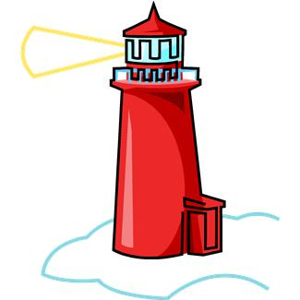

Pirate: Give me the turtle.

*(The pirate takes the turtle)*

Pirate: I like turtles. I like turtles with chips.

Narrator: And he goes back to the island in his small boat.

Mermaid: Oh no what can I do?

Shark: I am a shark. I can help. I can swim.

Mermaid: You can swim to the island but you cannot swim to the lighthouse

Lobster: I am a seahorse. I can help. I can swim.

Mermaid, Shark: You can swim to the island but you cannot swim to the lighthouse.

Jellyfish: I am a jellyfish. I can help. I can swim.

Mermaid,shark,lobster: You can swim to the island but you cannot swim to the lighthouse.

Squid: I am a starfish. I can help. I can swim.

Mermaid,shark,lobster: You can swim to the island but you cannot swim to the lighthouse.

Jellyfish, Dolphin: I'm dolphin. I can help. I can swim.

Mermaid,shark,lobster: You can swim to the island but you cannot swim to the lighthouse.

jellyfish,squid

Octopus: I am an octopus. I can help. I can swim.

Mermaid,shark,lobster: You can swim to the island but you cannot swim to the lighthouse.

jellyfish,squid,dolphin Oh no. I am very sad.

Crab: Hello, I am a crab. I can swim.

Everyone: You can swim to the island but you cannot swim to the lighthouse.

Crab: And I can walk.

Mermaid: You can walk?

Crab: Yes, I can walk.

Narrator: So the little crab swims to the island, walks to the lighthouse and rescues the turtle. The crab is happy. He is little, but he can walk *and* swim!

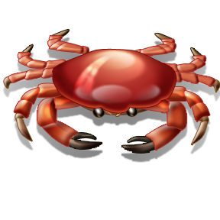**The End**

The Octopus Queen

1. Octopus Queen: .............................
2. Shark: ............................................
3. Jellyfish: ............................................
4. Seahorse: ........................................
5. Turtle: ............................................
6. Crab: ............................................
7. Ray: ............................................
8. Dolphin:.........................................
9. Squid: ...........................................
10. Fisherman: ..................................
11. Clown fish: ....................................
12. Narrator: ....................................

Octopus Queen: I am the Octopus Queen. I have got eight long yellow legs. I have got two small green eyes and I have got a big purple head.

Narrator: The shark comes

Shark: Octopus Queen, Octopus Queen, are you hungry?

Octopus Queen: Yes, I am.

Narrator: The jellyfish comes

Jellyfish: Octopus Queen, Octopus Queen, are you tired?

AN00031_

Octopus Queen: Yes, I am. *(yawning)*

Narrator: The ray comes.

Ray: Octopus Queen, Octopus Queen, are you hot?

Octopus Queen: Yes, I am.

Narrator: The seahorse comes

Seahorse: Octopus Queen, Octopus Queen, are you brave?

Octopus Queen: Yes, I am.

Narrator: The turtle comes.

Turtle: Octopus Queen, Octopus Queen, are you big?

Octopus Queen: Yes, I am.

Narrator: The dolphin comes.

Dolphin: Octopus Queen, Octopus Queen, are you clever?

Octopus Queen: Yes, I am.

Narrator: The squid comes.

Squid: Octopus Queen, Octopus Queen, are you strong?

Octopus Queen: Yes, I am.

Narrator: The crab comes.

Crab: Octopus Queen, Octopus Queen, are you happy?

Octopus Queen: Happy? No, no I am not. I am strong, I am fast, I am brave but I am not ........ beautiful.

AN00601_

Sea animals: Oh, yes, you are.

Octopus Queen: Oh, no I´m not

Sea animals: Oh, yes, you are.

Octopus Queen: Oh, no I´m not

Sea animals: Oh, yes, you are.

Octopus Queen: Oh, no I´m not. I am not beautiful. I am ugly, very ugly.

Narrator: The sea animals swim to the island. On the island lives a horrible fisherman.

Fisherman: I am a fisherman. I am strong, I am fast, I am brave and I am horrible, very very horrible. Ha, ha, ha. Hello sea animals, how are you?

Sea animals: Fine thank you. And you?

Fisherman: I am hungry. I am very hungry.

j0212907

Crab,Turtle: I have got an apple.

Fisherman: I don´t like apples.

Dolphin,Shark: I have got an orange.

Fisherman: I don´t like oranges.

Seahorse,Squid: I have got a banana.

Fisherman: I don´t like bananas.

Starfish: I have got a sandwich.

Fisherman: I don´t like sandwiches. I like .... sea animals! Ha, ha, ha!

*(The fisherman captures the sea animals and puts them in his fishing net)*

Octopus,shark,jellyfsih: Oh, no, help help!

Ray,turtle,starfish: Help help!

*(A little clown fish comes)*

Clownfish: Hello, I am a clownfish.

Fisherman: I am strong, I am fast, I am brave.

Clownfish: And you are horrible. Grrrr!!!!!!! *(The clownfish bites the fisherman and the fisherman runs away)*

Fisherman: Aaaaaaaaaa!!!!!!!!!!!!

Octopus Queen: Thank you clownfish. You are very brave.

Sea animals: Yes, you are very brave.

Clownfish: Thank you, and you are very beautiful.

Octopus Queen: Beautiful? I am not beautiful. I am ugly.

Clownfish: You are yellow, green and purple, the colours of the rainbow. A rainbow is very beautiful and so are you.

Octopus Queen: Yes, a rainbow is beautiful. And I am the colours of the rainbow. I am beautiful. I am happy.

Everyone: Hooray, hooray. The end.

The End

AN00601_