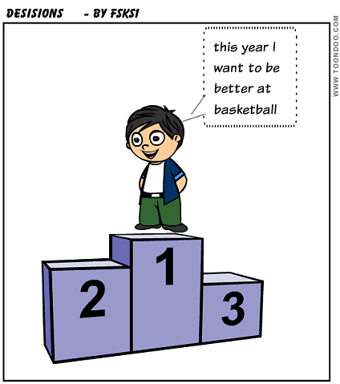DECISIONS/RESOLUTIONS
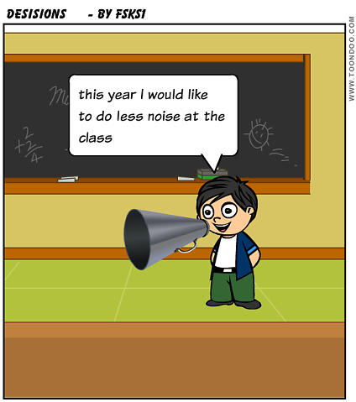
This year I would like to make less noise in class.
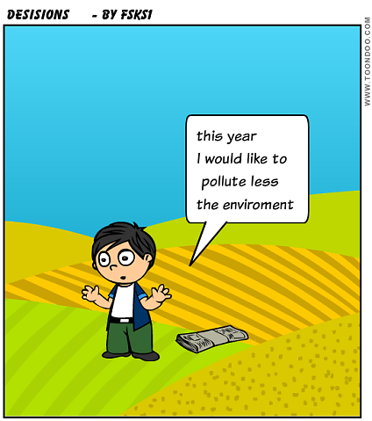
This year I have decided not to pollute the environment.
(By Philip)

