Our favourite film

Our favourite film is Harry Potter. In this film Harry Potter is a magician and he learns magic tricks at the school of Howgarts. Harry Potter with his magic power fights bad people like Malfoy. It isa great film full of fantastic adventures!!!
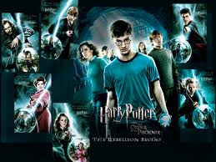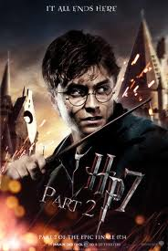

By Paul and Peter (E1)

