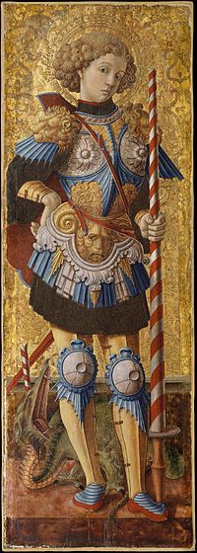
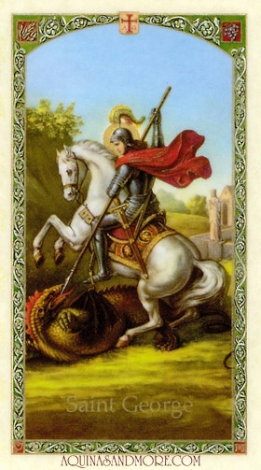
Saint George
(c. 275/281 – 23 April 303)
England's Patron Saint

Saint George (c. 275/281 – 23 April 303) was a Greek soldier who became an officer in the Roman army in the Guard of Diocletian. He is venerated as a Christian martyr. Saint George is one of the most venerated saints in the Catholic (Western and Eastern Rites), Anglican, Eastern Orthodox, and the Oriental Orthodox churches.
BY Theni

