PATRAS SUMMER ART FESTIVAL
Patras holds a lively summer arts festival with concerts, dance performances and theatre performances at the Roman Odeon/ Conservatory . It usually runs from mid-June to early October.

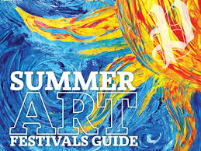

BY ANGELA GEORGOVASSILOPOULOU

