Well-known artists from abroad such as Michel Portal, Vincent Peirani and Stephan Micus are going to be present at the International Festival of Patras 2013, organized by the Cultural Organization of the Municipality of Patras in the summer.

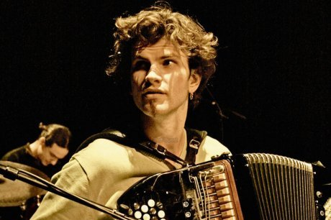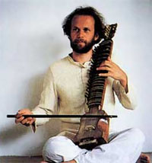
By Sylvia and Spyros

