PATRAS
THE LOCATION: Patras is situated in the south west of Greece. It is the capital of Peloponnese and a busy city where about 200.000 people live. It is the third biggest city in Greece and the third largest port. Six ( 6 ) km away from the city centre the Rion -Antirion bridge is located, which joins Peloponnese with the rest of Greece. It is one of the largest suspended bridges worldwide.
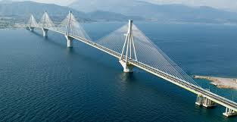
THE SURROUNDINGS: Patras combines both the sea and the mountains. That's why it is wet but not very cold in winter and also not very hot in summer.
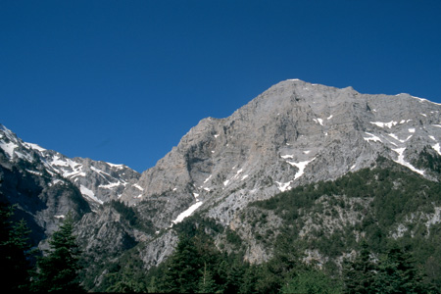PANACHAIKO MOUNTAIN
THE TOWN OLD & NEW: The city is around 32 centuries old and it has a beautiful old castle overlooking Patras and Rion Bridge. The view from its top is fantastic. In summer lots of performances take place inside the castle. Below the castle there is the old town with small houses and peaceful life. The new city is really busy, with lots of blocks of flats, cafes, taverns and shops.
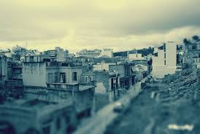The old town
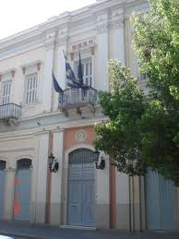The old Town Hall
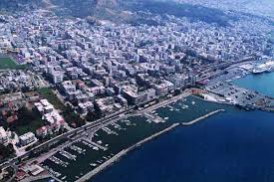
The city of Patras

