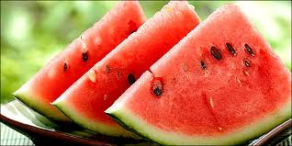Watermelon=καρπούζι (karpouzi)
My uncle sells watermelons.
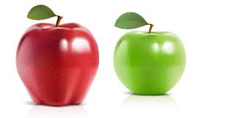Apple=μήλο (milo)
My brother likes apples.
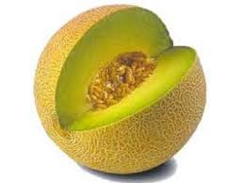Melon=πεπόνι (peponi)

I don’t like melon.
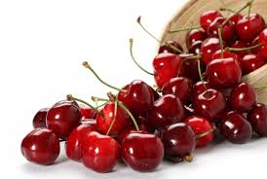Cherries=κεράσια (kerasia)
My sister likes cherries.
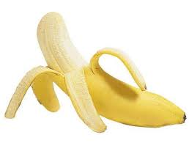Banana=μπανάνα (banana
Monkeys like bananas.
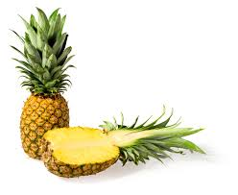Pineapple=ανανάς (ananas)
Pineapple is a healthy fruit.

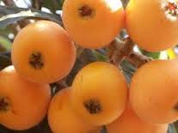Medullar=μούσμουλα (mousmoula)
My mother likes medullars.

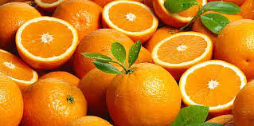 Orange=πορτοκάλι (portokali)
I drink orange juice every day.

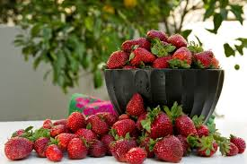 Strawberry=φράουλα (fraoules)
I like strawberries.

By:
Nikolas and Angelo

