English - Greek - fruit Dictionary
1. damson - κορομηλο – [koromilo]
2. strawberry - φρΑΟΥΛΑ - [FRAOYLA]
3. MELON - ΠΕΠΟΝΙ - [PEPONI]
4. WATERMELON - ΚΑΡΠΟΥΖΙ - [KARPOYZI]
5. fig - δαμασκηνο - [damaskino]
6. berries - μουρα - [moyra]]
7. cherries - κερασια – [kerasia]
8. bananas – μπανανα - [mpanana]
9. grapes – σταφυλια –[stafilia]
10. green apples – ΠΡΑΣΙΝΑ ΜΗΛΑ-[PRASINA MILA]

1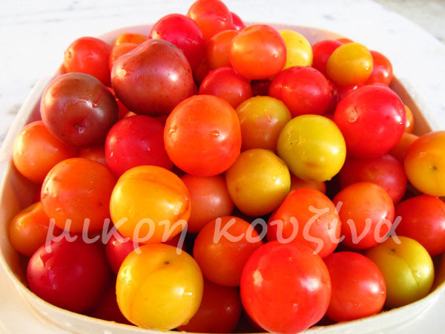
I like damsons

2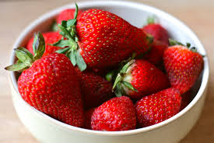
I like strawberries

3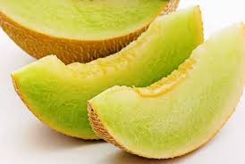I eat melon every summer

4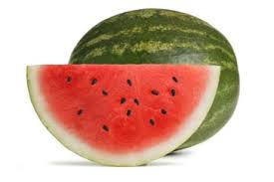
Do you like watermelon ?

5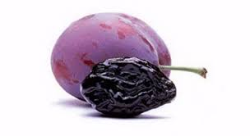
I don’t like plums
6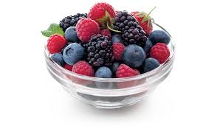
I like berries
7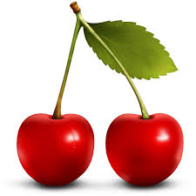
I like cherries

8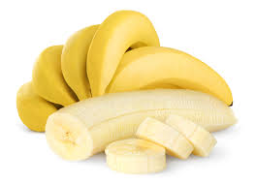I think banana’s colour is yellow

9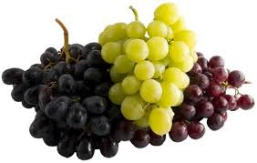

I like grapes because they are delicious

10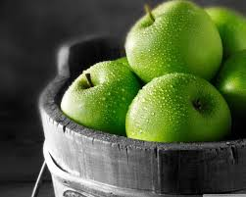
i like green apples

nikoleta-νικολετα
maira-μαιρα

