SEASON

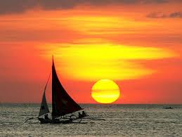
Our favorite season is …. Because we haven’t got school and we go to the beach every day. In this season the weather is sunny and hot. We also eat watermelons and melons. Every afternoon we play with our friends and we have fun!!!!!
Guess what season it is???
……………………….
NICK AND ANDREW !!!!!!

