our favourite book
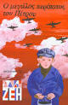
Our favourite book is 'Peter’s long walk'. This book talks about a family who lives in Athens. Peter lives happily with his friends and his family until the German occupation, when things change dramatically. He is not scared and he takes part in the Greek Ressistance. Indeed, he is a great hero…
Author: Alki Zei
Andrew
Nick

