New Zealand 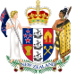

New Zealand is an island country in the southwestern Pacific Ocean. The country geographically comprises two main landmasses ‒ that of the North and South Islands ‒ and numerous smaller ones . New Zealand is situated some 1,500 kilometres east of Australia across the Tasman Sea and roughly 1,000 kilometres south of the Pacific Island Nations of New Caledonia, Fiji and Tonga. Because of its remoteness, it was one of the last lands to be settled by humans.
New Zealand was first settled by Eastern Polynesians between 1250 and 1300 (13th c)

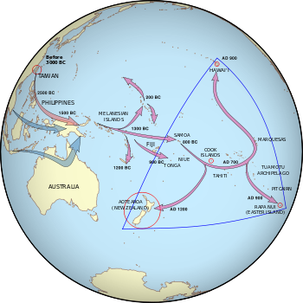

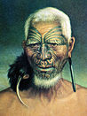 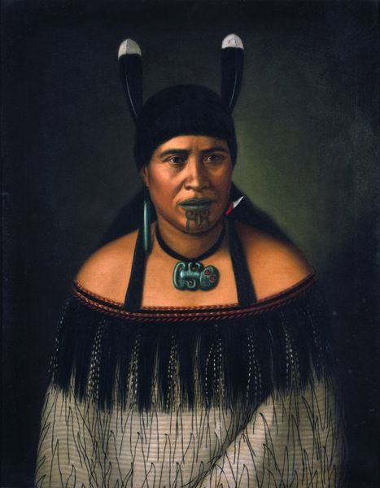 MAORI THEN
The Māori are the indegenous Polynesian people of New Zealand. Over several centuries in isolation, the Polynesian settlers developed a unique culture that became known as the "Māori".

A MAORI NOWADAYS

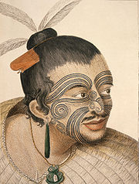 ART: A MAORI CHIEF WITH TATOOS

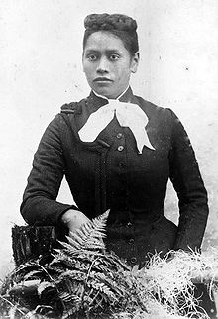Meri Te Tai Mangakahia: in 1890s she argued that women should have equal voting rights in the Maori Parliament

GEOGRAPHY

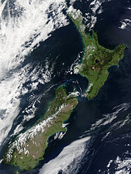
New Zealand is made up of:
1. North Island
2. South Island
(The main North and South islands are separated by the Cook Strait, 22 kilometres wide at its narrowest point)

The five largest inhabited islands are:
Stewart Island , the Chatham Islands, Great Barrier Island, D'Urville, Waiheke Island.
New Zealand's Length: It is long (over 1,600 kilometres along its north-north-east axis) and narrow (a maximum width of 400 kilometres , with approximately 15,134 km of coastline and a total land area of 268,021 square kilometres .

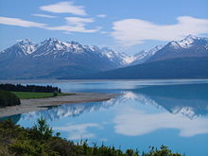 The snow-capped Southern Alps dominate the South Island, while the North Island's Northern Peninsula stretches towards the subtropics.

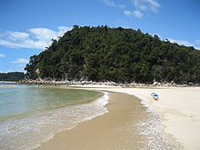 Torrent Bay at Abel Tasman National Park in the South Island
By the 5th grade pupils of the Model Experimental Primary school of the University of Patras

