Ania Schäfer
Myślęcinek is the largest urban park in Poland. It is located three kilometers from the cente of Bydgoszcz. It has more than 800 hectares. There are woods, hills, gorges with streams and beautiful ponds. You can stroll, relax and play sports.

There are:
cycle lanes, horses,
a botanical garden, zoo,

amusement park, children's playground
.

In winter you can go skiing and sledging.

One of the most popular places in Myślęcinek Forest Park is a glade called Różopole.
This is where concerts, festivals, picnics and sporting events take place.

SPEEDWAY

Speedway is one of the best sports in Poland.
Its origins go back to the 1920s.
The first speedway leaders received various awards,
such as cups, flowers and wine.
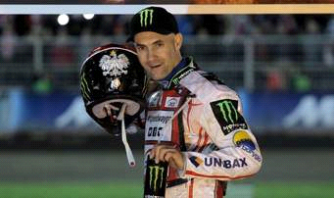
This is a Tomasz Gollob.
He won many awards.
He rode for the team of Polonia Bydgoszcz.
Now, unfortunately, you can't see him on the race track.
He went into retirement.
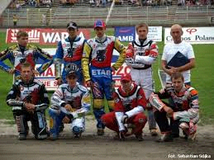
This is our team - Polonia Bydgoszcz.
In the photo you can see eight Polish riders.
The man in the white T-shirt is Polonia Bydgoszcz coach. His name is Jacek Woźniak.
The whole team has got twelve members:
Hans Andersen,Ashley Birks,Krzysztof Buczkowski,Greg Hancok,Robert Kościecha,Mateusz Szczepaniak,Bartosz Bietracki,Mikołaj Curyło,Karol Juźwik,Aleksander Łoktajew,Patryk Wolniewiński and Szymon Woźniak.
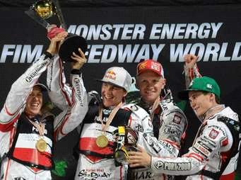
This is a platform.
On the platform are three winners.
Polish speedway riders have won medals. They also have flowers and champagne.
After the ceremony, they splash the champagne on each other.
Then the riders return to their garages.

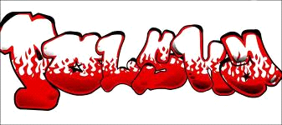
By Kuba and Jarek.

