WANTED
Reward: 7.000.000€
Wanted! Please, search for it everywhere. It’s small, green with 3 green eyes. It also has a red nose, two big orange ears, two big aerials and it’s wearing a yellow T-shirt.

Be careful!
It has superpowers
THIS IS A MONSTER IS CALLED <<HUGE>> AND IT ESCAPED FROM PRISON!
It’s very savage and vicious
It’s unpredictable!
(By Myrsini 6th grade)
Please help us find it
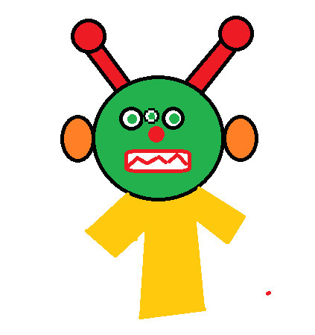
pleas

