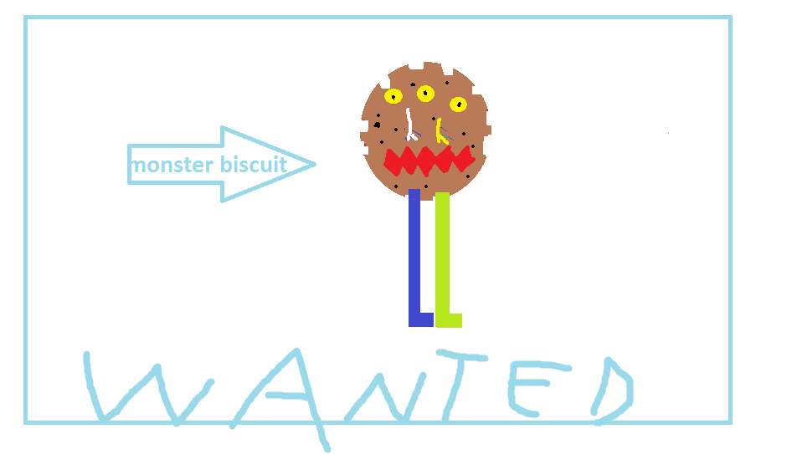

MONSTER BISCUIT ESCAPES FROM PRISON.
IT HAS THREE YELOW EYES, TWO NOSES, ONE MOUTH AND TOW LEGS. IT IS VICIOUS, CUNNING AND DANDEROUS.
IF YOU FIND IT CALL AT:3542367901 .
REWARD:1.000.000$

By Photis (6th grade)

