MELOMAKARONA
( SMALL HONEY CAKES)
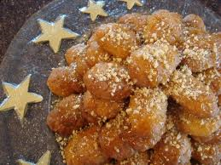
INGREDIENTS:
2 cups of olive oil
1 cup of sugar
1 cup of orange juice
1 cup of semolina
1 cup of soft flour
1 1/2 teaspoon baking soda
Grated orange and lemon peel

For the syrup:
1 cup of sugar
1 cup of honey
1 cup of water

Directions:
- Cream the olive oil with the sugar in an electric mixer, add the semolina slowly, the grated peel , the flour little by little and finally the soda. Beat well after each addition, until a soft non-sticky dough is achieved.
- Pinch off dough the size of a small tennis ball and make small oval-shaped cookies . Bake them at 200 C until golden brown.
- Take the cookies out of the oven and let them get cold.
- When they are cold enough put them in a pan and pour them with the hot syrup. Sprinkle with walnuts.
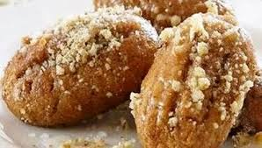

(BY LYDIA & KATHERINE)

