LESSON PLAN
Title: April Fool’s Day

Learners: sixteen (16) 5th grade primary- school pupils of post-elementary linguistic level, mixed ability, monolingual (Greek speaking), approx. 10-11 years of age
Lesson duration: 45-50 min

A brief description of the designed teaching session
The designed lesson starts with a warm up activity to set the scene and goes on with a listening text about a joke played on April Fool’s day. In the listening stage learners (Ls) are invited to listen to a text read by the teacher and put a set of pictures in the right order. The aim here is to train Ls into listening for the gist and stimulate their higher order thinking skills.
Post-listening/ communicative practice stage deals with a code-control game, where Ls are challenged to make up a number of grammatically accurate but strange/ funny interrogative sentences in the simple present tense, employing the pictures of the previous task. The group that presents the class with the most peculiar sentences is awarded the title of the "weirdest group" of the week!
The next phase focuses upon promoting close attention to language structures (present simple) by means of another code control game. Ls are encouraged to spot the six (6) grammatical mistakes included in a text. The group that manages to locate all the errors first, within time allotted, is nominated the winner of the day!
The lesson ends with a Bingo variation.

Teaching aims:
To encourage Ls to exploit L2 in a meaningful context by engaging them in a number of varying degrees of control tasks

Learning objectives
To assist Ls in handling spoken language effectively by means of
→ training them into listening for the gist and stimulating higher order thinking skills
→ practising the present simple tense in various contexts and relating it to particular functions
→ prompting interaction and reinforcing group work encouraging thus collaborative learning
→ promoting learning through skills integration and developing metacognition

Classroom facilities/Aids: Whiteboard, computer, overhead projector, photocopies

Assumptions
• Ls are keen on taking part in code-control games, therefore they are expected to get motivated
•They enjoy tasks which allow them to experiment with the language

Anticipated problems
• Lack of fluency due to their low linguistic competence may lead them to resort to mother tongue use, even when the focus is on interaction through L2
• Game -like tasks may inhibit the smooth progress of the lesson, as they work as a "stirrer"
• Cooperation within groups may also cause difficulties, as some learners may try to dominate the floor provided they are linguistically more advanced than others. As a result reserved or linguistically less able pupils may feel intimidated and thus reluctant to participate in the group tasks
•Time allotted may prove insufficient

Possible solutions
• Ls must be encouraged to make use of the target language as frequently as possible, and especially when the focus is on communicative speaking practice. If the T tries to assure them that there is no problem with making language slips and mistakes, pupil intimidation and reluctance in task participation might be mitigated, if not totally avoided
• Obstacles reserved pupils may face could be minimized by clear and precise instructions. Provision of ample time is another solution, which however may entail expanding task implementation time, fact that can 'undermine' the smooth progress and thus completion of the designed lesson plan. Yet, it is of vital importance to stress here that the language teacher's ultimate concern should be appropriate scaffolding provision in order to help young learners get essentially involved in the learning process, which in turn can progressively lead to language assimilation and acquisition and therefore to higher self esteem
• If a designed activity is not completed due to time shortage, then it should be carried out during the subsequent lesson. In this way learners are unlikely to lose sight of the learning objectives of the whole teaching instruction

Below follows the lesson plan schematically

THE LESSON PLAN SCHEMATICALLY

Stage/ Procedure | Learning objectives/skills | T/L Role /interaction | Time
warm up  T initiates a discussion about April Fool’s Day and asks Ls what people usually do on this day. T writes down vocabulary as it comes up during the discussion and pre-teaches unfamiliar lexis which they will need in the next stage | To activate prior knowledge on the subject & introduce new relevant vocabulary | T-Ls | 3-5'
Listening stage  Ls, divided in groups, are provided with a series of pictures in jumbled order. T relates a story and Ls put the pictures in the right order as they hear the story  They are allotted 2' to discuss any discrepancies | To expose  Ls to a listening input  and stimulate higher order thinking skills | T-Ls | 10'
Post-listening-writing stage/ communicative practice  Each group is invited to make up two (2) weird sentences employing the present simple tense + the pictures used in the listening stage  L2 use is exhorted, whereas each group appoints its secretary  A representative of each group speaks out the sentences. T writes them on the board and the groups, after negotiation, vote for the weirdest ones  The winner group is nominated "the weirdest group of the week"! | To draw Ls' attention on the use of present simple tense/interrogative form  To encourage accurate formulation of small chunks of written discourse  To promote negotiation skills | Ls-Ls | 10-15'
Intensive reading/language focus  Ls, in groups, are provided with a photocopy including the listening text heard in the previous stage. They are informed that the text has 6 grammar mistakes regarding the structure of the simple present tense  They are challenged to correct the mistakes within 5-7 min  The group that succeeds in recording all 6 errors within time allotted is nominated the group of the day | To focus Ls' mind on appropriacy and accuracy through a reflective game-like activity  To promote close attention to language structures (present simple) by means of a code control game | Ls-Ls | 5-7 '
Bingo game  T writes newly-learnt vocabulary on the board. Ls choose one word and T crosses out all but one. The winners are the pupils whose chosen lexis is read out by the T | To create a relaxing atmosphere and simultaneously promote newly-learnt vocabulary assimilation | T-Ls

THE TEACHING MATERIALS

The text to be read by the teacher
It is April Fool’s Day today and Bill decides to play a trick on Efi’s mother, Ms Red. Efi is one of his classmates. He leaves school in a hurry and goes straight to Efi’s house. When Bill meets Ms Red he tells her that Efi, her daughter, is badly hurt at school. Ms Red asks him, “Do her teachers know about it?” but Bill does not answer, he runs away instead. Ms Red, when she hears about her daughter’s accident, very much upset, goes out in the streets looking for her daughter…She is so upset that she nearly cries. A thousand thoughts are now in her mind. Well, after a little while she sees Efi at a distance, coming with some school friends. She runs towards her and asks her what is wrong. Efi gets really surprised when she sees her mother like that. Obviously she does not know anything about it. Mother explains everything to her. “Oh mother” says Efi, “It’s April Fool’s Day today, have you forgotten that?” Efi’s mother gets really angry with Bill and she decides to punish him. But she soon forgets it. Lucky Bill!
Well ..I believe people can play tricks on each other, but not something like that...Don’t you agree?

NOTE: The underlined vocabulary may be unfamiliar to a number of Ls
The photocopy Ls are challenged to correct
INSTRUCTION: In the following text there are six (6) grammar mistakes. Can you spot them within 5-7'?

It is April fool’s day and Bill decides to play a trick on Efi’s mother, Ms Red. Efi is one of his classmates. He leave school in a hurry and go straight to Efi’s house. When Bill meets Ms Red he tells her mother that Efi, her daughter, is badly hurt at school. Ms Red asks him, “Does her teachers know about it?” but Bill does not answers, he runs away instead. Ms Red, very much upset, goes out in the streets looking for her daughter…She is so upset that she nearly crys. A thousand thoughts are now in her mind. Well, after a little while she sees Efi at a distance, coming with some school friends. She runs towards her and asks her what is wrong. Efi gets really surprised when she sees her mother like that. Obviously she do not know anything about it. Mother explains everything to her. “Oh mother” says Efi, “It’s April Fool’s Day today, have you forgotten that?” Efi’s mother gets really angry with Bill and she decides to punish him. But she soon forgets it. Lucky Bill!
Well ..I believe people can play tricks on each other, but not something like that...Don't you agree?

Pictures to be used in the listening stage
INSTRUCTION: Listen to the text and put the following pictures in the right order
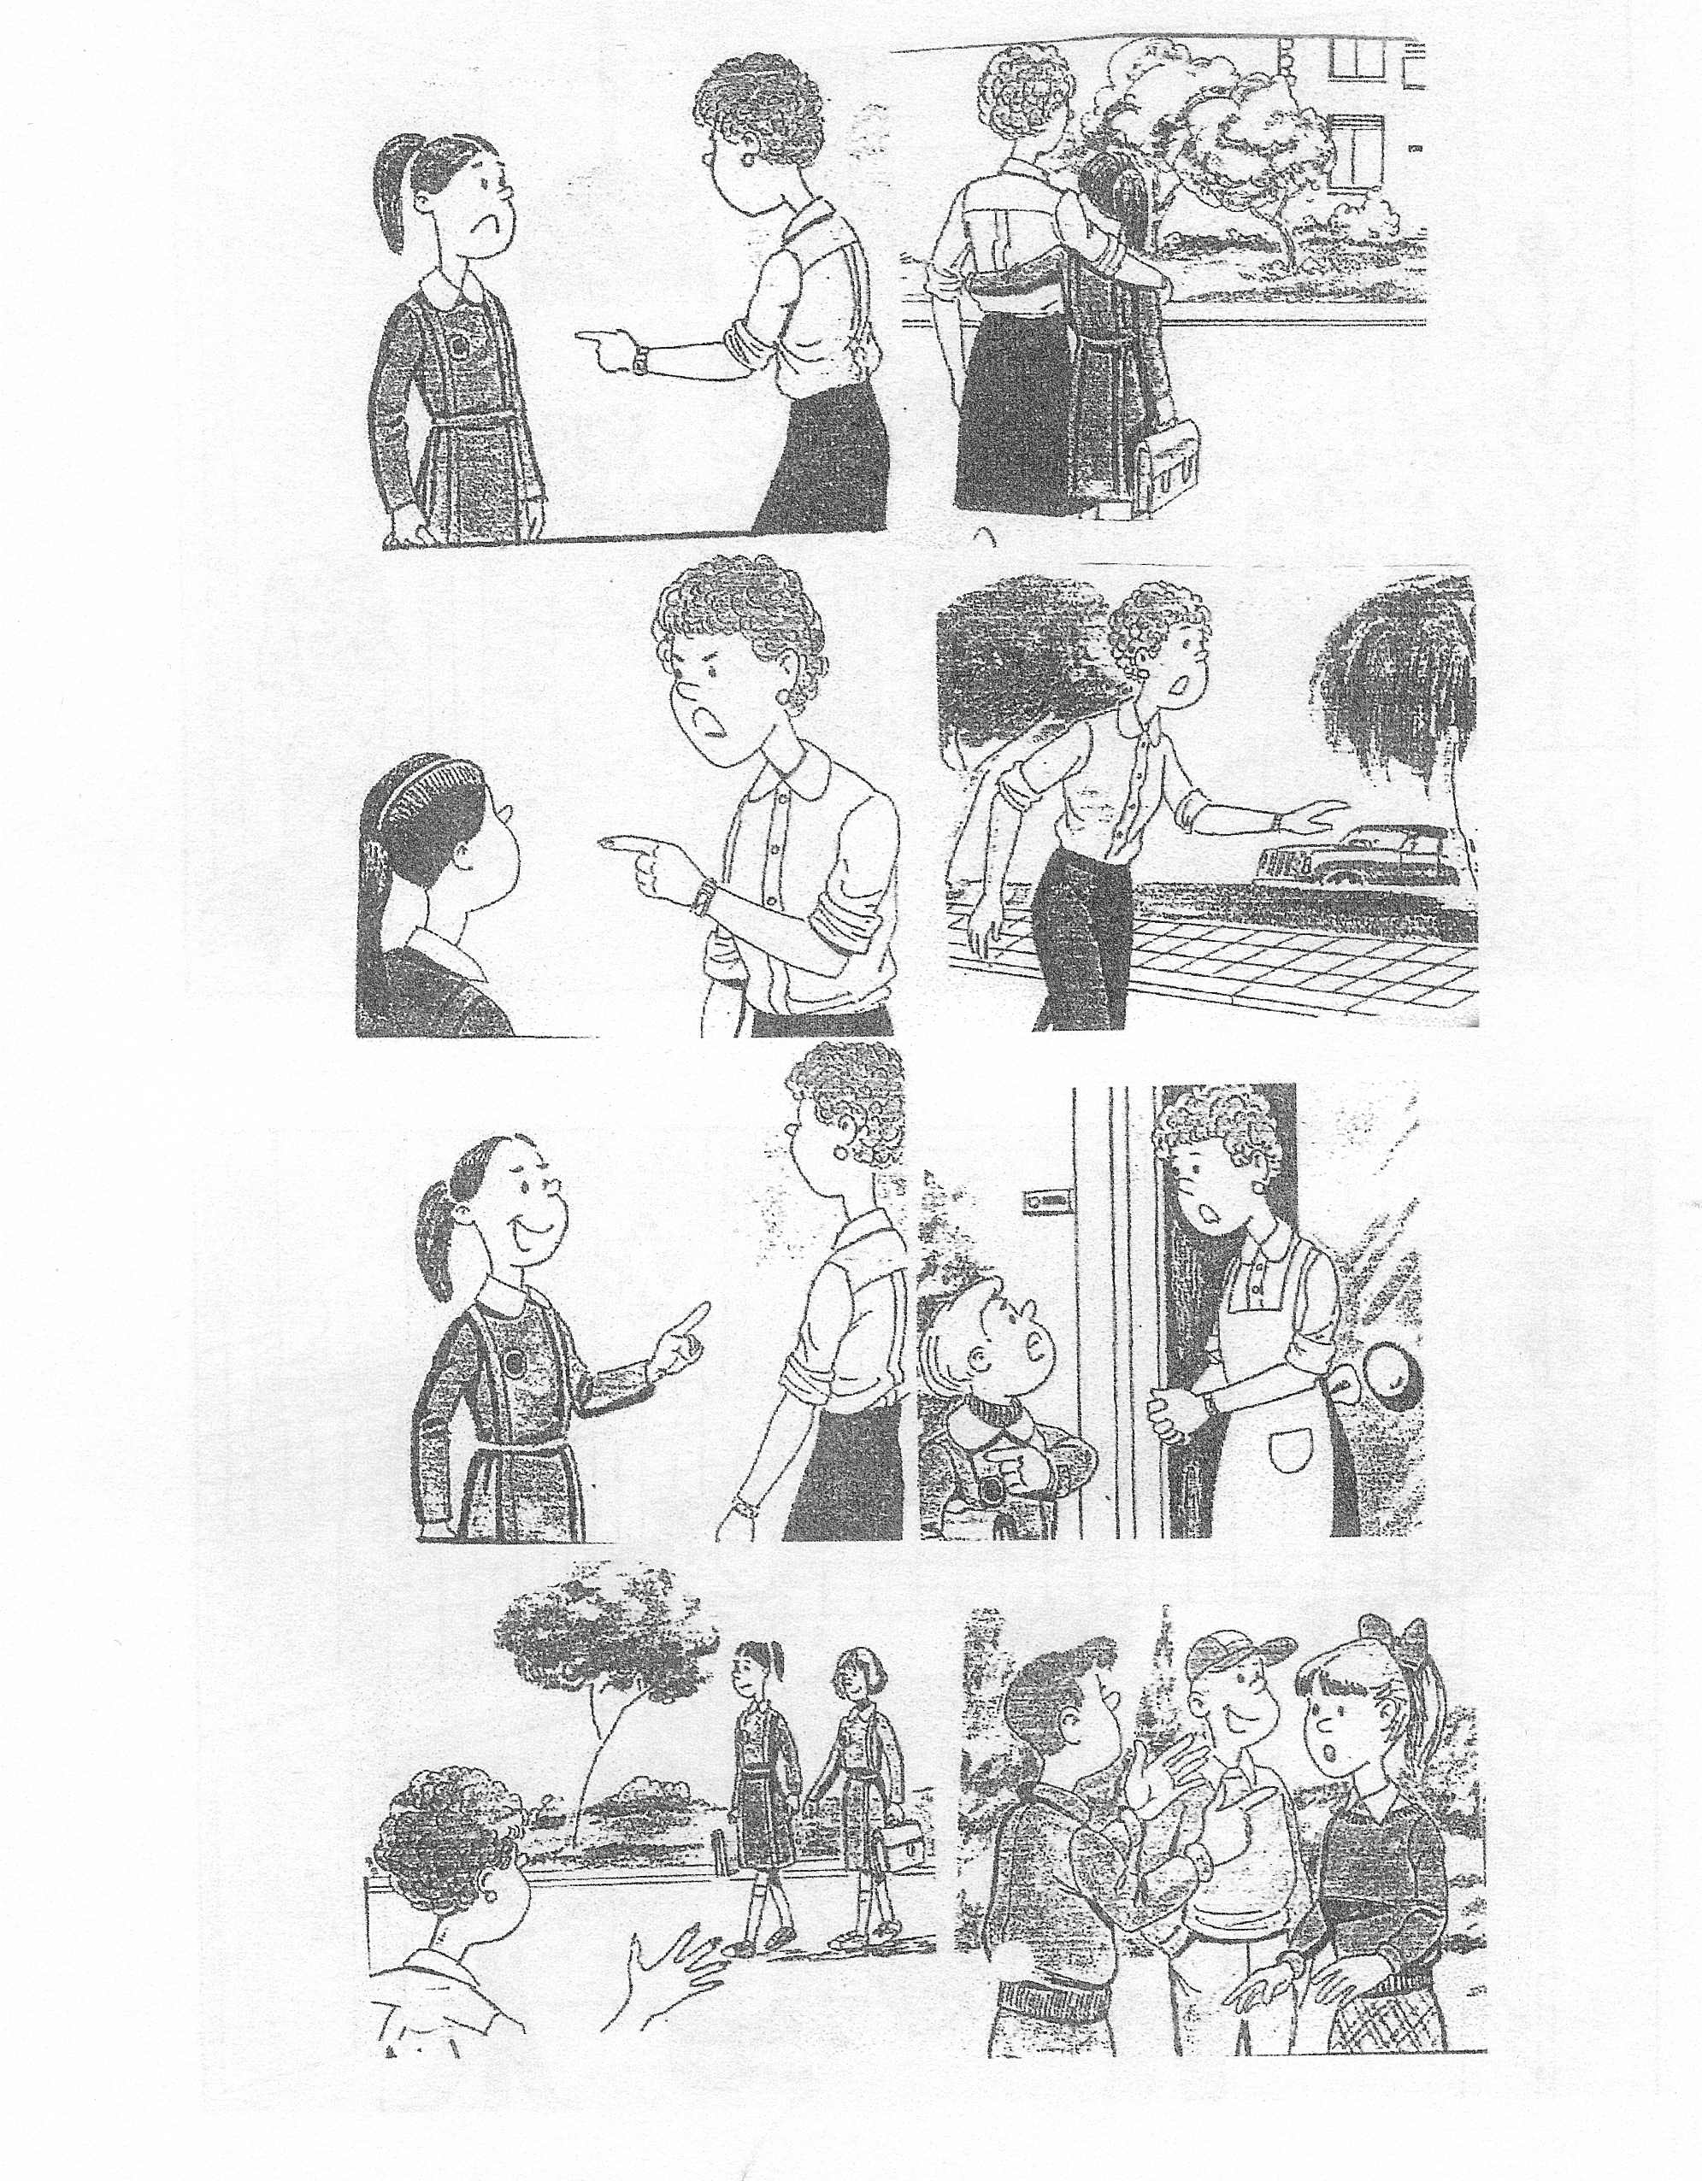
The photocopy the Ls are challenged to correct

It is April fool’s day and Bill decides to play a trick on Efi’s mother, Ms Red. Efi is one of his classmates. He leave school in a hurry and go straight to Efi’s house. When Bill meets Ms Red he tells her mother that Efi, her daughter, is badly hurt at school. Ms Red asks him, “Does her teachers know about it?” but Bill does not answers, he runs away instead. Ms Red, very much upset, goes out in the streets looking for her daughter…She is so upset that she nearly crys. A thousand thoughts are now in her mind. Well, after a little while she sees Efi at a distance, coming with some school friends. She runs towards her and asks her what is wrong. Efi gets really surprised when she sees her mother like that. Obviously she do not know anything about it. Mother explains everything to her. “Oh mother” says Efi, “It’s April Fool’s Day today, have you forgotten that?” Efi’s mother gets really angry with Bill and she decides to punish him. But she soon forgets it. Lucky Bill!
Well ..I believe people can play tricks on each other, but not something like that...Don't you agree?

NOTE: It stands to reason that the wrong verb forms are underlined for teacher's use only. Ls will be provided with the same photocopy, but the errors will not be spotted whatsoever

