KARATE KID
My favourite film is KARATE KID. It talks about a child who loves karate. The child starts hard training. At the end of the story the child wins the world cup of karate. I saw it for the first time on the TV. Immediately it impressed me.

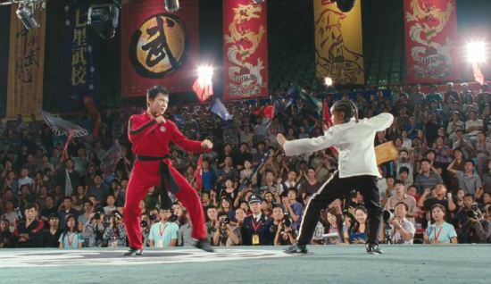 By Leonidas

