GUESS THE SEASON

Our favourite season is -----. We like this season because we go to the beach. We haven’t got school and we haven’t got any homework. We sometimes go on holiday and make new friends.
The weather is sunny and hot ,too.
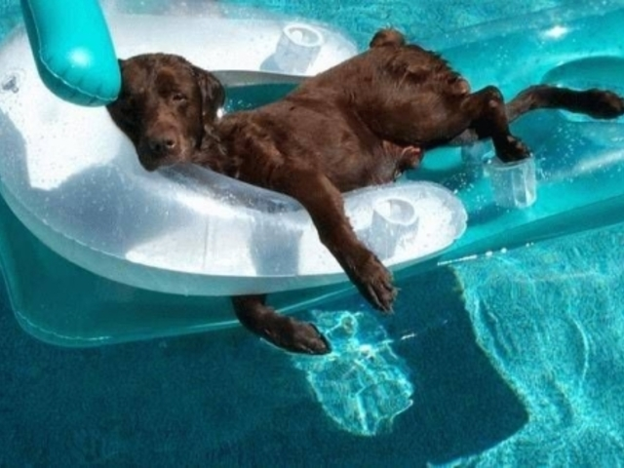

KONSTANTINOS
ANASTASIS

