our Favorite Book is …
our favorite book is called 'The adventures of Baron munchausen' .
THIS BOOK IS ABOUT ONE MAN WHO HAS A LOT OF Adventures.
THE MOST SERIoUS ,FUNNY AND DENGEROUS one IS WHEN HE HAS to FAcE A BEAR!!!!!!!!!!!!Read it and find out more!
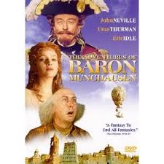
BY KON AND CHRIS

