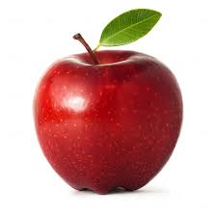
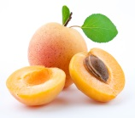
Apricot= βερύκοκο (verikoko) I like apricots.

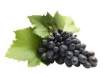
Apple= μήλο (milo) Apples are red.

Grapes= σταφύλια (stafilia) There are two kinds of grapes.
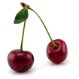
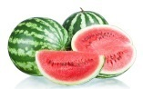
Cherries= κεράσια (kerasia) I eat cherries in the spring.

Watermelon= καρπούζι (karpuzi) Watermelon is huge.
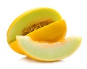
Melon= πεπόνι (peponi) There is one melon in the fridge.
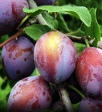
Damson= κορόμηλο (koromilo) I have a damson in my bag.
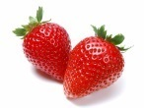
Strawberries= φράουλες (fraules) Strawberries are small fruits.
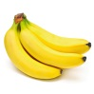
Bananas= μπανάνα (banana) Banana is my favourite fruit.
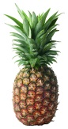
Pineapple= ανανάς (ananas) Pineapples have got lots of 'spines'.
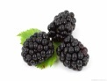
Blackberry= βατόμουρο (vatomuro) Blackberry is a rare fruit.
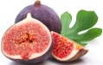
Fig= σύκο (siko) Figs are delicious.
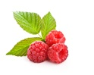
Berry= μούρο (muro)

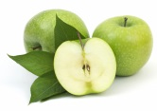
Green apple= ξινόμηλο (xinomilo)
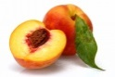
peach=ροδάκινο (rodakino)
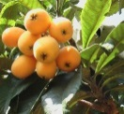
Medlars =μούσμουλα (mousmoula)

