IRELAND (independent country)
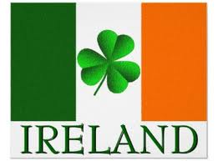 NORTHERN IRELAND (part of the UK)
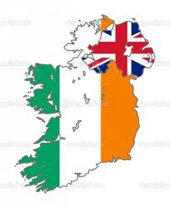

IRELAND (EIRE): An island situated in the north-west of Europe. The third largest island in Europe and the 20th largest on earth.

BORDERS:
North-West: Northern Atlantic ocean, South: the Celtic sea, East: Irish sea + North channel
Geographically is made up of the Republic of Ireland (that covers five-sixths of the island) and Northern Ireland (situated in the northern-east of the island and it is part of Great Britain)
Population: 6.4 million (4.6 live in the Republic of Ireland and 1.8 million in the Northern Ireland)
Island's geography: low mountains , plains, navigable rivers (Shannon the longest river: 386 km long).
Biology: there are 55 mammal species, 26 of them are native to Ireland (e;g. the red deer, the red fox, hedgehog, badger) and 400 species of birds.

Capital cities: The Republic of Ireland: Dublin (population 1 million)
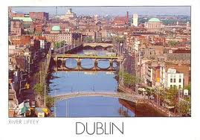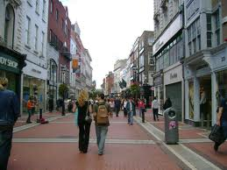

Northern Ireland : Belfast
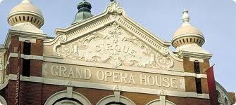

Religion: Irelands largest group is Christianity (Roman Catholicism 73 per cent for the island and 83 for the Republic of Ireland
Official languages: Irish(Republic of Ireland) and English (Northern Ireland)
Art: 20th century: 4 winners of the Nobel Prize for Literature : George Bernand Shaw, William Yeats, Samuel Beckett and Seamus Heaney. James Joyce one of the most significant writers of the 20th century
Sports: Gaelic football, hurling, handball, horse racing, greyhound
Important dates: 1801 Ireland becomes part of the UK
1840: the great famine (1 million Irish die and 1 million emigrates)
December 1921: Ireland gains its Independence (The republic of Ireland) but Northern Ireland remains part of the UK)

