ENGLAND
IMPORTANT CITIES

London

#1 most popular location
As a city that seamlessly blends the old world with the seductively modern, London is an atypical British city

Blackpool
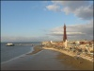
#2 most popular location

Manchester
#3 most popular location
A city best known for its football teams: Manchester United, the most supported and most hated team in England,

Liverpool

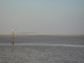
#4 most popular location
As the city that bought you The Beatles

York
#5 most popular location
One of the most beautiful cities in Britain, boasting some of the most amazing architecture and surrounding countryside in the whole of Europe.

Birmingham
#6 most popular location
One of the most progressive cities in England. It is considered to be the second largest in terms of population/ Birmingham is a massive metropolitan area in the West Midlands region .

Bath

#7 most popular location
Named after its natural hot spring Roman baths, the city of Bath is an English hidden gem.

Brighton
#8 most popular location
Generally known by its nickname of “London by the sea”, Brighton is a seaside city less than 50 miles south of London in the County of East Sussex.

Bournemouth
#10 most popular location
Bournemouth is a town in the South West of England, perhaps best known for its wide, sandy beach and its Victorian pier.

Bristol
#11 most popular location

Cambridge
#12 most popular location
With a skyline dominated by King’s College Chapel, Cambridge University Library, Addenbrooke’s Hospital, and St. John’s College Chapel.

Oxford
#13 most popular location
Home to the oldest university in the English-speaking world and a haven for the intellectual elite.

Leeds
#16 most popular location
The largest city in Yorkshire, Leeds is a modern hub of activity, famous for its metropolitan appeal, its vibrant nightlife, the multiple universities and sports teams

Canterbury #26 most popular location
Canterbury is the home to 2 large universities and is very student populated. It is full of history - The Cathedral, St Augustines Abbey and Canterbury Castle to name just a few.
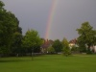

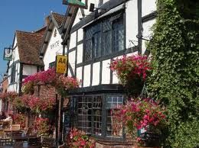

Stratford-upon-Avon #32 most popular location
SHAKESPEAR'S BIRTHPLACE
Stratford-upon-Avon is a market town and civil parish in south Warwickshire, England. It lies on the River Avon…

BY PANTELIA & MYRSINI

