We spend our free time doing lots of things. We enjoy riding our bicycles and reading books. We usually play basketball, also we have fun with electronic games. Sometimes we play some board games like: UNO, Monopoly e.t.c.
By Sylvia and Spyros
---------------------------------------------------------------

How we spend our free time

In our free time we like playing basketball , reading books, drawing pictures, watching TV and playing boards games . We usually hung out with our friends. We also like playing various games and computers games!!!
By Anna and Peter
--------------------------------------------------------------

We like spending our free time playing Nerf war, that is a game with plastic guns which
throws darts. We also like spending our free time playing play station, x-box and doing tricks with our bikes.
By Nick George
-------------------------------------------------------------------

HOW WE SPEND OUR FREE TIME

I spend my free time playing football and doing tae-kwon-do. I also go to play in the park with my friends. In the afternoon I play board games and at night I watch TV.
By Paul

I spend my free time listening to music and playing board games. I also like playing computer games and I like playing with my friends, too.
By Lydia
-----------------------------------------------------------------

HOW WE SPEND OUR FREE TIME
In our free time we do a lot of things, such as reading a book and comics, playing Play Station, watching TV, playing board games with friends and listening to music. We also have a lot of fun swimming in the sea.
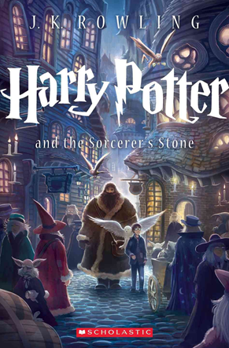 BY CHRIS AND ANGELINA

