HOW WE SPEND OUR PASTIME
When we have free time we take advantage of this and play traditional games. We prefer playing basketball and football. We prefer these games because they are team games. And we learn to cooperate with other people, we keep fit and meet new friends. To sum up, we enjoy the traditional games and NOT video games because the latter aren’t social, at all.
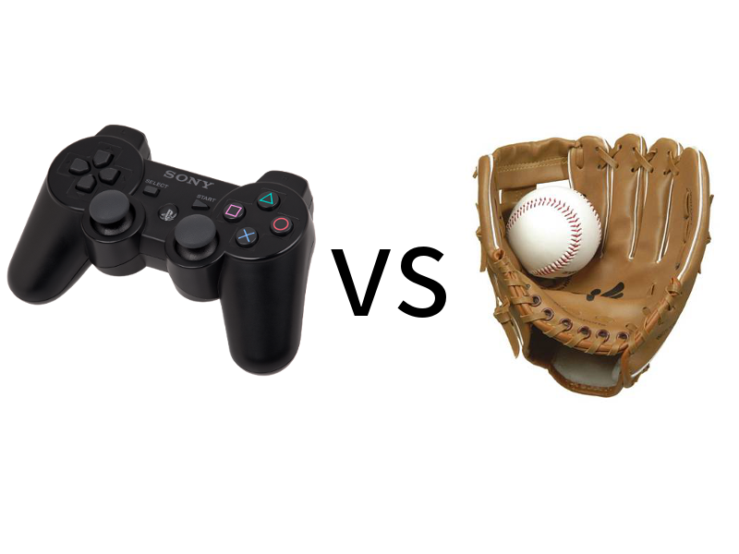
by michael & george

