history of patras

Patras has an important history of four thousand years (4.000!!!!!).Patras has been inhabited since the prehistoric age. Patras reached the top of its power since the Roman Era. During the Byzantine period it became a commercial city. It experienced repeated conquests from Latins, Venice, Byzantines and in the end Ottomans. In Patras, started the Greek Revolution in 1821 against the Ottoman/Turkish bondage . In 19th century, it was the second biggest city in Greece.
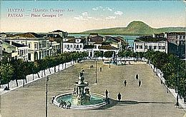

Elias

